Name: _____________________
Address: ___________________
Email: _____________________
Phone: ____________________

Liz Van Genderen
Helena National Forest
2880 Skyway Dr.
Helena, MT 59602
hlcplanrevision@fs.fed.us

SUBJECT: Wilderness Inventory Comments; Forest Plan Revision

Helena - Lewis & Clark National Forest

Dear Ms. Van Genderen:

Thank you for accepting my comments on the wilderness inventory for the Helena - Lewis & Clark National Forests (“HLCNF”). In accordance with the directions provided by the HLCNF, I am pleased to submit to you the following comments on wilderness inventory areas.

As recognized in the Standard of Review section, infra, all “[l]ands included in the inventory will be carried forward for evaluation.” (FSH 1909.12, § 71 (2015).) Accordingly, I am not only providing comments which are relevant to wilderness inventory, but also with regards to certain wilderness evaluation criteria pursuant to § 72, et seq, of the Forest Service Handbook. In the event I do not submit additional comments during the evaluation phase, I hereby incorporate by reference the entirety of these comments for consideration by the HLCNF during the evaluation phase, as though these comments were fully restated therein at such subsequent time.

///

///

///

///

///
TABLE OF CONTENTS
INTRODUCTION 3
STANDARD OF REVIEW 5
WILDERNESS EVALUATION INVENTORY COMMENTS 8
I. Big Belts Wilderness Evaluation Inventory 8
II. Castles Wilderness Evaluation Inventory. 22
III. Crazies Wilderness Evaluation Inventory. 22
IV. Divide Wilderness Evaluation Inventory. 22
V. Elkhorns Wilderness Evaluation Inventory. 28
VI. Highwoods Wilderness Evaluation Inventory – Polygon H2. 34
VII. Little Belts Wilderness Evaluation Inventory. 35
VIII. Rocky Mountain Range Wilderness Evaluation Inventory. 38
IX. Snowies Wilderness Evaluation Inventory – Polygon S1. 40
X. Upper Blackfoot Wilderness Evaluation Inventory 41

INTRODUCTION

The Wilderness Act of 1964, 16 U.S.C. § 1131 et seq., is intended to assure that an increasing population, accompanied by expanding settlement and growing mechanization, does not occupy and modify all areas within the United States and its possessions, leaving no lands designated for preservation and protection in their natural condition. See 16 U.S.C. § 1131(a) (2016). In furtherance of its stated purpose, the Wilderness Act defines “wilderness” as follows:

A wilderness, in contrast with those areas where man and his own works dominate the landscape, is hereby recognized as an area where the earth and its community of life are untrammeled by man, where man himself is a visitor who does not remain. An area of wilderness is further defined to mean in this Act [16 USCS §§ 1131 et seq.] an area of undeveloped Federal land retaining its primeval character and influence, without permanent improvements or human habitation, which is protected and managed so as to preserve its natural conditions and which (1) generally appears to have been affected primarily by the forces of nature, with the imprint of man's work substantially unnoticeable; (2) has outstanding opportunities for solitude or a primitive and unconfined type of recreation; (3) has at least five thousand acres of land or is of sufficient size as to make practicable its preservation and use in an unimpaired condition; and (4) may also contain ecological, geological, or other features of scientific, educational, scenic, or historical value.

16 U.S.C. § 1131(c).

An important consideration for further wilderness recommendations is how that would impact the multiple uses of those lands for future generations. Pursuant to the Multiple-Use Sustained-Yield Act (“MUSY”) of 1960, “multiple use” is defined to include:

[t]he management of all the various renewable surface resources of the national forests so that they are utilized in the combination that will best meet the needs of the American people; making the most judicious use of the land for some or all of these resources or related services over areas large enough to provide sufficient latitude for periodic adjustments in use to conform to changing needs and conditions; that some land will be used for less than all of the resources; and harmonious and coordinated management of the various resources, each with the other, without impairment of the productivity of the land, with consideration being given to the relative values of the various resources, and not necessarily the combination of uses that will give the greatest dollar return or the greatest unit output.

16 U.S.C. § 531(a) (2015) (emphasis added). Additionally, the preamble of the MUSY Act states: “Be it enacted by the Senate and House of Representatives of the United States of America in Congress assembled, that, it is the policy of the Congress that the national forests are established and shall be administered for outdoor recreation, range, timber, watershed, and wildlife and fish purposes.” (emphasis added). Accordingly, both MUSY and the National Forest Management Act (“NFMA”) of 1976, 16 U.S.C. §§ 1600, et seq., requires that land management plans, including wilderness recommendations, address multiple uses.

In December 2014, the United States Congress passed the National Defense Authorization Act for Fiscal Year 2015, P.L. § 113-291 (“NDAA”), which included, in relevant part, the language of the Rocky Mountain Front Heritage Act which added acres to both the Bob Marshall and the Scapegoat Wilderness Areas. “With the additions from the NDAA, designated wilderness within the [HLCNF] now comprises roughly 565,158 acres, which is approximately 20% of the overall plan area.” (HLCNF Forest Plan Assessment, Ch. 8, Existing Designated Areas, at 2 (2015) (emphasis added).) In addition to its existing wilderness areas, the HLCNF contains a substantial amount of Inventoried Roadless Areas (“IRA”). “There are approximately 1,449,892 acres of lands within IRAs within the plan area. These IRAs constitute approximately 50% percent of the entire lands administered by the [HLCNF].” Id., at 9 (emphasis added). Accordingly, a majority of the lands within the HLCNF are designated as either IRA or wilderness areas.

Again, however, MUSY and NFMA requires that the National Forests are managed for multiple uses. “One way to look at opportunity for solitude is using the recreation opportunity spectrum [(“ROS”)] which is a framework to describe different settings across the landscape and attributes associated with those settings. The social setting attribute in ROS discusses the probability of solitude; two ROS classes, primitive and semi-primitive nonmotorized have a high probability of solitude.” (HLCNF Forest Plan Assessment, Ch. 6, Mult. Uses & Ecosystem Serv., at 46 (2015).) “About 16% of the plan area is in the primitive class . . . [and the] percent of the plan area in the semi-primitive non-motorized class during the summer is about 36%.” Id. Accordingly, the second criteria of 16 U.S.C. § 1331(c) must be considered within the entire landscape of the HLCNF: there are already existing opportunities for “solitude” within 52% of the HLCNF.

The IRAs that are near or in close proximity to existing wilderness areas serve as an important transition between lands with road-based resource management activities and lands affected substantially by natural processes. Maintaining the roadless character of these transition areas, without making them additions to the National Wilderness Preservation System (“NWPS”), effectively sustains existing levels of Wilderness value protection in two ways:

First, inventoried roadless areas adjacent to or near Wilderness areas are usually more accessible than Wilderness areas and are an alternative for recreation uses. Second, the additional distance from intense management activities would provide more opportunities for natural processes (for example allowing fire to play its natural role or maintaining the integrity of wildlife habitat) to occur uninterrupted.

(F.S. Roadless Area Conservation FEIS, at 3-238 (Nov. 2000) (emphasis added).)

Some of the key characteristics of inventoried roadless areas lie in their unique Primitive, Semi-Primitive Non-Motorized, and Semi-Primitive Motorized recreation opportunities. Activities that are prohibited in designated Wilderness areas and that are not readily available in areas with classified roads can occur in inventoried roadless areas. These areas provide popular, appropriate alternatives to Wilderness areas because, although they contain many Wilderness attributes, a wider range of recreation opportunities with fewer restrictions is available.

(F.S. Roadless Area Conservation FEIS, at 3-238 (Nov. 2000) (emphasis added).)

Based on the foregoing, special consideration should therefore be given to not adding additional wilderness; particularly with regards to the specific areas identified and requested as such herein. The multiple uses mandate under MUSY and NFMA should necessarily dictate that certain areas are not recommended for inclusion within the NWPS. In this regard, it is also important to recognize the steady growth and popularity of mountain biking in the HLCNF and its positive effects on its local residents. In light of these important social and economic considerations, I respectfully request that the wilderness inventory areas identified herein are not recommended for inclusion within the NWPS because, pursuant to National Forest Policy 1923.03(3), “Any area recommended for wilderness or wilderness study designation is not available for any use or activity that may reduce the wilderness potential of an area.” Were the HLCNF to include or designate these certain areas as recommended wilderness, such action would correspondingly result in a ban of mountain biking use in those areas.

Thank you for taking the time to review these comments and for considering the impacts that additional wilderness would have on mountain biking in the HLCNF.

STANDARD OF REVIEW

In developing a new Forest Plan, HLCNF’s Responsible Person is required to “[i]dentify and evaluate lands that may be suitable for inclusion in the National Wilderness Preservation System and determine whether to recommend any such lands for wilderness designation.” 36 C.F.R. § 219.7(c)(2)(v) (2016). “The process occurs in four primary steps: inventory, evaluation, analysis, and recommendation.” (FSH 1909.12, § 70.60 (2015).)

The current phase of this process, the inventory phase, is summarized in § 71 of the Forest Service Handbook as follows:

The primary function of the inventory step is to efficiently, effectively, and transparently identify all lands in the plan area that may have wilderness characteristics as defined in the Wilderness Act.

The inventory is intended to be reasonably broad and inclusive, based on the inventory criteria set out in this section and additional information provided to the Responsible Official through the required opportunities for public and government participation (sec. 70.61 of this Handbook). The intent is to identify lands that may be suitable, so that they can be evaluated and to allow for public input and feedback (sec. 70.61 of this Handbook). Lands included in the inventory will be carried forward for evaluation. Inclusion in the inventory is not a designation that conveys or requires a particular kind of management.

(FSH 1909.12, § 71 (2015) (emphasis added).)

Pursuant to Section 71 of the Forest Service Handbook:

Include an area in the inventory when:
1. The area meets the size criteria defined in section 71.21 [of 5,000 or more acres] and has no improvements; or
2. The area meets the size criteria defined in section 71.21 and is consistent with the improvements criteria defined in sections 71.22a and 71.22b.

After applying the size and improvements criteria, the Responsible Official shall also review the information provided through public participation during the assessment or as part of the wilderness recommendation process (sec. 70.61 of this Handbook), including areas that have been proposed for consideration as recommended wilderness through a previous planning process, collaborative effort, or in pending legislation. The Responsible Official may include in the inventory additional areas identified as part of that review that do not meet the criteria in sections 71.21 and 71.22 of this Handbook, for the purpose of carrying such areas forward to the evaluation step.

(FSH 1909.12, § 71.2 (2015).)

As previously indicated, I am incorporating these comments for future consideration in the evaluation phase, as though fully restated therein. Accordingly, it is important to review the criteria that the HLCNF must consider under the evaluation phase.

The Forest Service Handbook provides the following summary guidance for evaluation of wilderness characteristics, in relevant part:

The Interdisciplinary Team shall evaluate areas, which must include all lands identified in the inventory (sec. 71 of this Handbook), to determine potential suitability for inclusion in the National Wilderness Preservation System using criteria included in the Wilderness Act of 1964, section 2(c), as follows:

1. Evaluate the degree to which the area generally appears to be affected primarily by the forces of nature, with the imprints of man’s work substantially unnoticeable (apparent naturalness). Consider such factors as:
a. The composition of plant and animal communities. The purpose of this factor is to determine if plant and animal communities appear substantially unnatural (for example, past management activities have created a plantation style forest with trees of a uniform species, age, and planted in rows);
b. The extent to which the area appears to reflect ecological conditions that would normally be associated with the area without human intervention; and
c. The extent to which improvements included in the area (sec. 71.22 of this Handbook) represent a departure from apparent naturalness.

2. Evaluate the degree to which the area has outstanding opportunities for solitude or for a primitive and unconfined type of recreation. The word “or” means that an area only has to possess one or the other. The area does not have to possess outstanding opportunities for both elements, nor does it need to have outstanding opportunities on every acre.
a. Consider impacts that are pervasive and influence a visitor’s opportunity for solitude within the evaluated area. Factors to consider may include topography, presence of screening, distance from impacts, degree of permanent intrusions, and pervasive sights and sounds from outside the area.
b. Consider the opportunity to engage in primitive-type or unconfined recreation activities that lead to a visitor’s ability to feel a part of nature. Examples of primitive-type recreation activities include observing wildlife, hiking, backpacking, horseback riding, fishing, hunting, floating, kayaking, cross-country skiing, camping, and enjoying nature. . . .

5. Evaluate the degree to which the area may be managed to preserve its wilderness characteristics. Consider such factors as:
a. Shape and configuration of the area;
b. Legally established rights or uses within the area;
c. Specific Federal or State laws that may be relevant to availability of the area for wilderness or the ability to manage the area to protect wilderness characteristics;
d. The presence and amount of non-Federal land in the area; and
e. Management of adjacent lands.

(FSH 1909.12, § 72.1 (2015) (emphasis added).) It is important to note that “[t]he Responsible Official is not required to carry all lands evaluated forward for further NEPA analysis as potential recommendations for inclusion in the National Wilderness Preservation System.” (FSH 1909.12, § 72 (2015) (emphasis added).)

The Wilderness Act of 1964 and the National Environmental Policy Act do not contain their own provisions for judicial review. See Russell Country Sportsmen v. United States Forest Serv., 668 F.3d 1037, 1041 (9th Cir. 2011). Accordingly, judicial review of the HLCNF's decision under these statutes is governed by the judicial review provisions of the Administrative Procedure Act (“APA”), 5 U.S.C. §§ 701-06. See City of Sausalito v. O'Neill, 386 F.3d 1186, 1205-06 (9th Cir. 2004). Under the APA, agency decisions may be set aside if “arbitrary, capricious, an abuse of discretion, or otherwise not in accordance with law.” 5 U.S.C. § 706(2)(A) (2016).

WILDERNESS EVALUATION INVENTORY COMMENTS

A general theme throughout these comments is the preservation of existing semi-primitive nonmotorized recreational access and the opportunity to expand these uses in the HLCNF. It is particularly important to preserve this sustainable form of recreation in areas where documented and long-standing mountain bike use has occurred, in areas where expansion of trails can be used to alleviate pressure on existing trail systems, and where certain areas lack the requisite level of wilderness characteristics. In the following specific polygons and/or geographic areas where I have identified as such, I respectfully request that the HLCNF not carry those areas forward for further NEPA evaluation.

Big Belts Wilderness Evaluation Inventory

The Big Belt Mountains are an island range primarily in Broadwater, Lewis and Clark, and Meagher counties with small portions in Gallatin and Cascade counties. “Roads have been constructed for resource extraction and now fragment much of the [Divide] GA. The road network serves as the primary platform from which visitors experience the area.” (HLCNF Draft Desired Conditions, at 54 (Nov. 2015).)

“Recreation opportunities appear to be a key factor in the ability of [Lewis & Clark] county to attract new businesses.” (HLCNF Roads Analysis Report, at 18 (2004) (emphasis added).) “The economy of [Broadwater] county has traditionally been based upon on agriculture and logging. Currently both of these industries are in a slump and the county’s economy is depressed. . . . The community is looking more towards recreation related industries to provide additional income to the communities.” Id. (emphasis added). “Recreation provides large benefits to [Meagher] county. . . OHV use is common in the area and recent Forest Service and BLM closures are a source of frustration for some recreationists.” Id., at 19 (emphasis added). “Helena bike shops report that purchases of mountain bikes are steadily rising and that riders are seeking trail networks on National Forest lands other than abandoned roads.” (North Belts Travel Plan: FEIS, at 53 (Jan. 2005).)

It is important to note that “[m]ost of the IRAs in the North Belts travel planning area do not currently possess strong wilderness characteristics. These remaining motorized routes may continue to impact remoteness and solitude due to their proximity to IRA’s.” (North Belts Travel Plan: F.S. Record of Decision, at 13 (May 2005) (emphasis added; citations omitted).) Furthermore, “[d]ue to the presence of adjacent developments, past use, and non-enforceable boundaries, many of the InventoriedRoadless Areas in the North Big Belts possess limited wilderness character.” (North Belts Travel Plan: FEIS, at 49 (Jan. 2005) (emphasis added).)

Pursuant to MUSY, the Big Belts must be managed with the following identified purposes, as recognized by the HLCNF: “Need for continued access to, and maintenance of, rural and backcountry trails and use areas for hiking, biking, skiing, equine, and motorized (OHV, snowmobile) recreation.” (North Belts Travel Plan: FEIS, at 54 (Jan. 2005) (emphasis added).) Nevertheless, “[b]ecause the Inventoried Roadless Areas do not possess strong wilderness attributes, the existing motorized routes may have minimal impacts to the roadless resource.” (North Belts Travel Plan: FEIS, at 60 (Jan. 2005) (emphasis added).)

As previously indicated, Helena, Montana – the Big Belts’ nearest population center – has become a destination for mountain biking over the past decades. For example, in 2013, the Helena Tourism Alliance launched Bike Helena in an effort to brand Helena as a biking destination. See Erin Madison, Helena Makes its Mark as a Mountain-Biking Destination, Seattle Times (Sept. 9, 2015), available at: http://www.seattletimes.com/life/travel/helena-makes-its-mark-as-a-mountain-biking-destination/. Helena is now also recognized as a silver-level riding center destination – one of only 19 recognized centers in the world – by the International Mountain Bicycling Association (“IMBA”). See id. IMBA’s silver-level designation earned Helena and the HLCNF recognition in mountain-biking magazines, on websites and on top mountain-bike destination lists.

The ever-increasing popularity of mountain biking in general, and specifically in the Helena area, has resulted in growing numbers of mountain bikers flocking to ride HLCNF’s trails. In turn, this has resulted in growing congestion and use on the already existing trails that are open to this semi-primitive nonmotorized ROS class. It is therefore necessary that the surrounding areas – including the Big Belts – remain open for trail expansion and semi-primitive nonmotorized use in the future. A large percentage of HLCNF lands are currently preserved for their wilderness characteristics due to their wilderness designations. However, were the HLCNF to expand the NWPS by including certain lands within the Big Belts, such actions would forever prevent and preclude mountain bikers from ever using those lands. Accordingly, I respectfully request that the HLCNF consider these impacts in its evaluation of wilderness inventory areas, and further, that the HLCNF neither carries forward nor includes the following areas for NEPA analysis to the extent I have specifically requested herein.

- Big Belts #2 – Polygon BB2
- Areas for mountain bike trail expansion within BB2

As a result of the ever-increasing popularity of mountain biking in the Helena area, described supra, there is a corresponding need to relieve congestion on existing trails open to mountain biking. In addition to its existing roads and trails, the BB2 Polygon represents an area where semi-primitive nonmotorized trails could be built and maintained in the future. Doing so would alleviate some of the pressures on the already existing trails and further support the multi-use management goals required under MUSY and NFMA. However, in the event that the BB2 Polygon was recommended for inclusion in the NWPS, such action would forever prevent mountain bikers from using those lands and would similarly prevent “sufficient latitude for periodic adjustments in use to conform to changing needs and conditions.” 16 U.S.C. § 531(a). I therefore respectfully request that the BB2 Polygon is not carried forward for NEPA analysis.

- Wilderness attributes of BB2

Because Polygon BB2 does not contain sufficient wilderness characteristics, I respectfully request that it is not included for further wilderness evaluation. As the North Belts Travel Plan even acknowledges:

The natural integrity of this roadless area has been impacted by human activity. Mining, grazing, and firewood gathering have resulted in roads, trails, prospect holes, fences, spring development, and woodcutting. Private lands in the Soup Creek and Trout Creek drainages have year-round residences, access roads, and fences. An overhead, twin-tower power line crosses the west edge of the area. A buried cable crosses the northwest corner and extends from Cottonwood Gulch to Hogback Mountain. That power line is a popular OHV route during the summer and fall. An electronics site, with buildings and antenna towers, is located on top of Hogback Mountain. In addition, a Forest Service lookout tower, located on Hogback Mountain, is staffed during the summer fire season. The Hogback Mountain Road provides motorized access to those facilities. . . .

The Never Sweat road and portions of the Never Sweat trail are located within the roadless area. The Never Sweat trail, constructed and maintained for motorized vehicles, is quite popular and provides access to other motorized routes located in the Cave Gulch and Kingsberry Gulch areas. . . .

Because of the broken, sharp topography there are opportunities for solitude in individual drainages. Opportunities diminish near the roadless boundaries where roads and trails offer greater access. The northwest end of the Big Belts, which includes the roadless area, receives both commercial and military air traffic. Airplane, jet, and helicopter noise sometimes decrease the feeling of solitude. . . .

The Middleman/Hedges Mountain Roadless Area boundaries are defined by roads in some locations, but are not well defined by topographic features elsewhere. Relocating the existing boundary to make it follow locatable topographic features would be difficult due to the lack of well-defined topographic breaks.

Extensive private in-holdings in Soup Creek, to the north of Hogback Mountain, and along the boundary would complicate roadless area management. Re-drawing boundaries to eliminate private land would either fracture the unit into two or more smaller areas, or substantially reduce the overall unit size.

Non-conforming uses include an electronic site, overhead and buried electrical cables, buried pipeline, four-wheel drive roads, fences, trail bike use, mining claims, and oil and gas lease rights. Due to existing roadless boundaries and the large amount of motorized use near and within the area, it would be very difficult to manage this area as wilderness in the future.

(North Belts Travel Plan: Appendix B, at 424-26 (Jan. 2005) (emphasis added).)

- Big Belts #3 – Polygon BB3
- Existing mountain biking trails and roads within BB3

I respectfully request that Big Belts Polygon BB3 is not recommended as a wilderness area because of the following roads and trails that would be closed for mountain biking use:

Trail/Road Polygon #
Beartrap Gulch Trail #4137 BB3
Trout Creek Canyon Trail #270 BB3
Vigilante Recreation Trails #247 & #248 BB3
Bar Gulch Trail #241 to Cave Gulch Trail #243 & #245 BB3
Holiday & Kingsberry Gulch Road #4136A to Hedges Mountain BB3
Neversweat Gulch Road #425C BB3

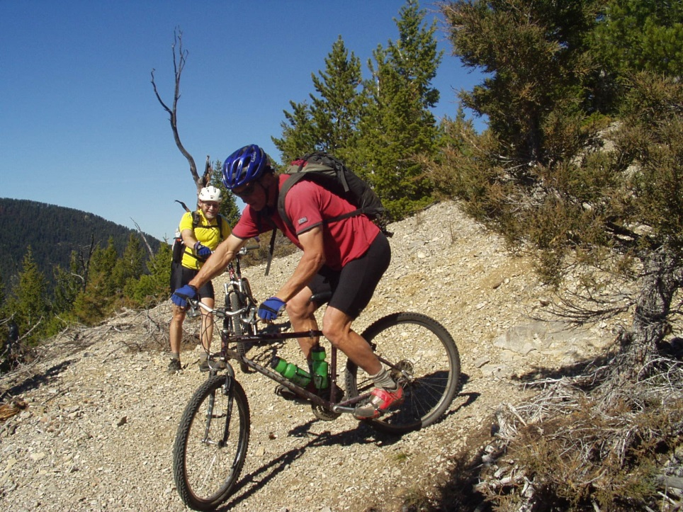
(Hanging Valley Trail #247. Photo credit: Greg Beardslee)
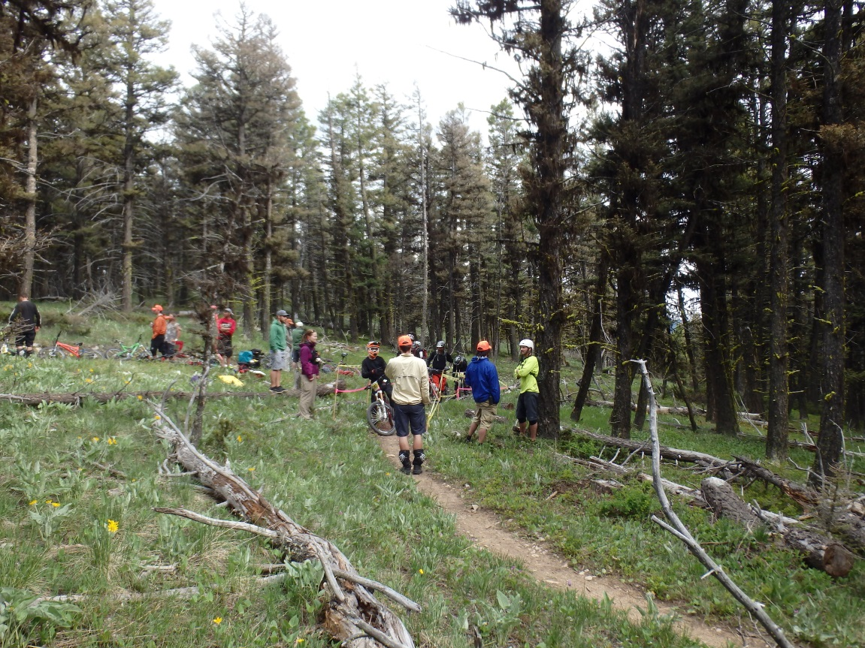
(Montana Enduro Series race on Beartrap Gulch Trail #4137. Photo Credit: Montana Bicycle Guild, Inc.)
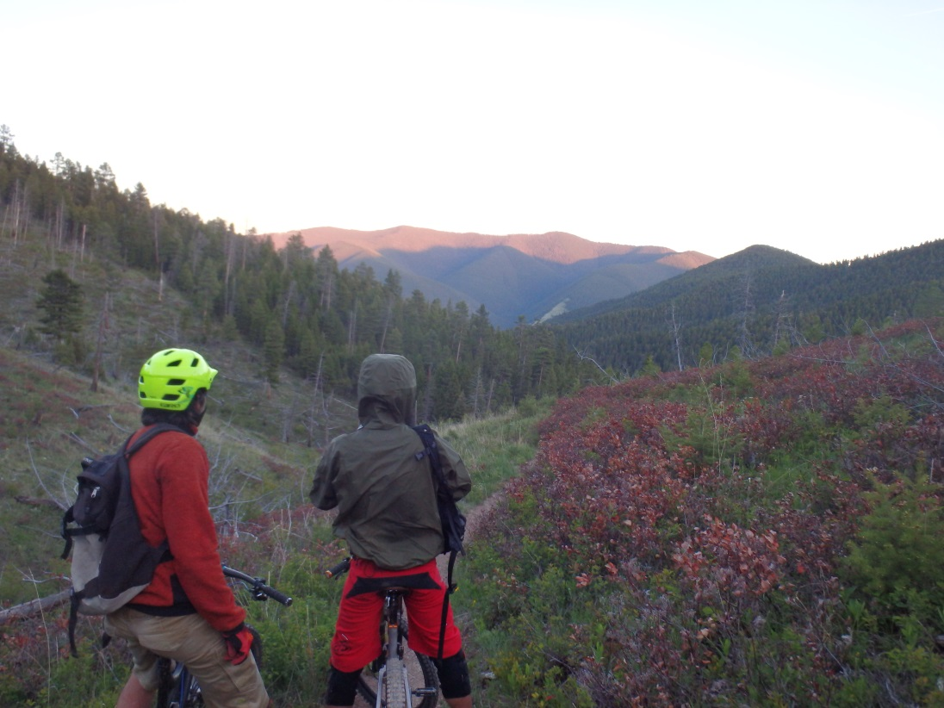
(Beartrap Gulch Trail #4137. Photo Credit: Montana Bicycle Guild, Inc.)
///

///

- Areas for mountain bike trail expansion within BB3

As a result of the ever-increasing popularity of mountain biking in the Helena area, described supra, there is a corresponding need to relieve congestion on existing trails open to mountain biking. In addition to its existing roads and trails, the BB3 Polygon represents an area where semi-primitive nonmotorized trails could be built and maintained in the future. Doing so would alleviate some of the pressures on the already existing trails and further support the multi-use management goals required under MUSY and NFMA. However, in the event that the BB3 Polygon was recommended for inclusion in the NWPS, such action would forever prevent mountain bikers from using those lands and would similarly prevent “sufficient latitude for periodic adjustments in use to conform to changing needs and conditions.” 16 U.S.C. § 531(a). I therefore respectfully request that the BB3 Polygon is not carried forward for NEPA analysis.

- Wilderness attributes of BB3

Because Polygon BB3 does not contain sufficient wilderness characteristics, I respectfully request that it is not included for further wilderness evaluation. As the North Belts Travel Plan even acknowledges:

The natural integrity of this roadless area has been impacted by human activity. Mining, grazing, and firewood gathering have resulted in roads, trails, prospect holes, fences, spring development, and woodcutting. Private lands in the Soup Creek and Trout Creek drainages have year-round residences, access roads, and fences. An overhead, twin-tower power line crosses the west edge of the area. A buried cable crosses the northwest corner and extends from Cottonwood Gulch to Hogback Mountain. That power line is a popular OHV route during the summer and fall. An electronics site, with buildings and antenna towers, is located on top of Hogback Mountain. In addition, a Forest Service lookout tower, located on Hogback Mountain, is staffed during the summer fire season. The Hogback Mountain Road provides motorized access to those facilities. . . .

The Never Sweat road and portions of the Never Sweat trail are located within the roadless area. The Never Sweat trail, constructed and maintained for motorized vehicles, is quite popular and provides access to other motorized routes located in the Cave Gulch and Kingsberry Gulch areas. . . .

Because of the broken, sharp topography there are opportunities for solitude in individual drainages. Opportunities diminish near the roadless boundaries where roads and trails offer greater access. The northwest end of the Big Belts, which includes the roadless area, receives both commercial and military air traffic. Airplane, jet, and helicopter noise sometimes decrease the feeling of solitude. . . .

The Middleman/Hedges Mountain Roadless Area boundaries are defined by roads in some locations, but are not well defined by topographic features elsewhere. Relocating the existing boundary to make it follow locatable topographic features would be difficult due to the lack of well-defined topographic breaks.

Extensive private in-holdings in Soup Creek, to the north of Hogback Mountain, and along the boundary would complicate roadless area management. Re-drawing boundaries to eliminate private land would either fracture the unit into two or more smaller areas, or substantially reduce the overall unit size.

Non-conforming uses include an electronic site, overhead and buried electrical cables, buried pipeline, four-wheel drive roads, fences, trail bike use, mining claims, and oil and gas lease rights. Due to existing roadless boundaries and the large amount of motorized use near and within the area, it would be very difficult to manage this area as wilderness in the future.

(North Belts Travel Plan: Appendix B, at 424-26 (Jan. 2005) (emphasis added).)

- Big Belts #4 – Polygon BB4
- Existing mountain biking trails and roads within BB4

I respectfully request that Big Belts Polygon BB4 is not recommended for a wilderness area because of the following roads and trails that would be closed for mountain biking use:

Trail/Road Polygon #
Hunters Gulch Trail #239 BB4
Carpenter Gulch Trail #238 BB4
Little Hellgate Gulch Trail #240 BB4
Gabish Gulch Trail #233 BB4
Hellgate Gulch to Thompson Gulch Trail #264 BB4
Doolittle Gulch to Bilk Mountain (BB5) Trail #232 BB4

- Areas for mountain bike trail expansion within BB4

As a result of the ever-increasing popularity of mountain biking in the Helena area, described supra, there is a corresponding need to relieve congestion on existing trails open to mountain biking. In addition to its existing roads and trails, the BB4 Polygon represents an area where semi-primitive nonmotorized trails could be built and maintained in the future. Doing so would alleviate some of the pressures on the already existing trails and further support the multi-use management goals required under MUSY and NFMA. However, in the event that the BB4 Polygon was recommended for inclusion in the NWPS, such action would forever prevent mountain bikers from using those lands and would similarly prevent “sufficient latitude for periodic adjustments in use to conform to changing needs and conditions.” 16 U.S.C. § 531(a). I therefore respectfully request that the BB4 Polygon is not carried forward for NEPA analysis.

- Wilderness attributes of BB4

Because Polygon BB4 does not contain sufficient wilderness characteristics, I respectfully request that it is not included for further wilderness evaluation. As the North Belts Travel Plan even acknowledges:

This roadless area is crisscrossed by motorized travel routes consisting of a four wheel drive road up Hellgate Gulch and motorcycle/ATV trails along Little Hellgate Gulch, Hunters Gulch, Thompson Creek, Fisher Gulch, Gabish Gulch, and Doolittle Gulch. Most of these routes are on the ridge tops and are utilized regularly when weather permits. Fences and old timber harvest units are visible along the southern boundary. These features, along with the motorized activity associated with them, have impacted the natural integrity with the appearance of human activity to some extent. . . .

The Hellgate Gulch Roadless Area is approximately 15 air miles east of Helena and 23 miles north of Townsend, Montana. There are no motorized vehicle travel restrictions for this roadless area. Most motorized vehicle use consists of ATV's and motorcycles from spring into the fall when weather permits. This use occurs on roads/trails up Little Hellgate Gulch and onto to the ridge northeast on trails 240 and 239, in Thompson Creek and Hellgate Gulch on trail 264. Other motorized travel routes include Hunters Gulch, Fisher Gulch, Gabish Gulch and Doolittle Gulch. The Magpie Creek road #425 and the Avalanche Creek road #359 form the western and eastern boundaries, respectively, providing several access points to the previously identified trails. No snowmobile activity occurs in this area.

Topography, and to a lesser extent vegetation screening, is effective in creating opportunities for solitude in pockets away from motorized travel routes, such as Shannon Gulch, Spilling Gulch, and McGregor Gulch. Opportunities for solitude are greatest during the winter months, as this is the period of least recreation use. During the big game hunting season, it is difficult to avoid contact with others. Other activities in this roadless area include rock climbing on the limestone cliffs in Hellgate Gulch, mineral prospecting, horseback riding, and some hiking. . . .

The long established motorized vehicle use on the roads and trails in this roadless area is a major distraction from a wilderness environment.

(North Belts Travel Plan: Appendix B, at 426-28 (Jan. 2005) (emphasis added).)

- Big Belts #5 – Polygon BB5
- Existing mountain biking trails within BB5

I respectfully request that Big Belts Polygon BB5 is not recommended for a wilderness area because of the following roads and trails that would be closed for mountain biking use:

Trail/Road Polygon #
Doolittle Gulch (BB4) to Bilk Mountain Trail #232 BB5
Cayuse Gulch Trail #235 BB5
Needham Gulch Trail #2084 BB5
Nary Time Gulch Trail #234 BB5
White Gulch Road #587 BB5
Springs Gulch Road #1020 BB5
Upp No. 2 Gulch Road #597A BB5

- Areas for mountain bike trail expansion within BB5

As a result of the ever-increasing popularity of mountain biking in the Helena area, described supra, there is a corresponding need to relieve congestion on existing trails open to mountain biking. In addition to its existing roads and trails, the BB5 Polygon represents an area where semi-primitive nonmotorized trails could be built and maintained in the future. Doing so would alleviate some of the pressures on the already existing trails and further support the multi-use management goals required under MUSY and NFMA. However, in the event that the BB5 Polygon was recommended for inclusion in the NWPS, such action would forever prevent mountain bikers from using those lands and would similarly prevent “sufficient latitude for periodic adjustments in use to conform to changing needs and conditions.” 16 U.S.C. § 531(a). I therefore respectfully request that the BB5 Polygon is not carried forward for NEPA analysis.

- Wilderness attributes of BB5

Because Polygon BB5 does not contain sufficient wilderness characteristics, I respectfully request that it is not included for further wilderness evaluation. As the North Belts Travel Plan even acknowledges:

These motorized travel routes are part of a popular trail network frequented by motorcycle, ATV, and four-wheel drive enthusiasts, mainly during the summer and fall. Little snowmobile activity occurs in this area.

This area's narrow geographic shape and existing roads limit the opportunity for remoteness and solitude. During the big game hunting season, it is difficult to avoid contact with others. The sights and sounds from adjacent developments are difficult to avoid. Except for hunting, the area does not offer any outstanding opportunities for non-motorized recreation. . . .

The long established motorized vehicle use of the Nary Time trail #234 and the ridge road #4161 is a major distraction from the wilderness environment in this area. The area closure in the southern half of the roadless area has been effective in eliminating motorized use. Most of the boundary is manageable. Along the eastern side, in the area of Spring Creek, and south to the head of Long Gulch, the boundary is located at mid-slope and not along logical topographic features.

(North Belts Travel Plan: Appendix B, at 428-31 (Jan. 2005) (emphasis added).)

- Big Belts #6 – Polygon BB6
As the Travel Plan for Polygon BB6 recognizes, “Recreational activities [in this area] include: hiking, backpacking, fishing, horseback riding, hunting, trapping, mountain biking, backcountry skiing, and snowshoeing.” (South Belts Travel Plan: Appendix C, at 129 (Nov. 2007) (emphasis added).) The HLCNF should recognize that the following roads and trails have been used by and are currently available for mountain biking within Polygon BB6:

Trail/Road Polygon #
Boulder Creek Trail #142 BB6
Debauch Gulch Trail #144 to Boulder Baldy Trail #118 BB6
Middle Fork Duck Creek Trail #2726 BB6
Atlanta Creek Road #4185 BB6
Camas Ridge Road #575 BB6
Camas Ridge Trail #140 BB6
Camas Lake Trail #140A BB6
Rickfoot Creek Trail #141 BB6
Camas Creek Road #383 BB6

I respectfully request consideration of the access to and use of these trails in the HLCNF’s evaluation of Polygon BB6. In addition, despite the wilderness characteristics present in Polygon BB6, I respectfully request the HLCNF also consider the possibility of designating and managing Polygon BB6 as a National Recreation Area. By administratively designating Polygon BB6 as a National Recreation Area, it would allow the area to be managed with an emphasis on its outstanding recreational attributes occurring in its natural condition. See 36 C.F.R. § 294.1 (2016). In particular, the HLCNF could maintain Polygon BB6’s wildlife and wilderness characteristics, while at the same time specifically permitting the continued use of semi-primitive non-motorized recreation.

- Big Belts #7 – Polygon BB7

The HLCNF should recognize that the following roads and trails have been used by and are currently available for mountain biking within Polygon BB7:

Trail/Road Polygon #
Duck Creek Pass to Mount Baldy Trail #2890/Road #4023 BB7
Duck Creek Pass to Hidden Lake/Edith Lake Trail #151 and Trail #150 BB7
Gipsy Lake to Edith Lake Trail #150 BB7
Edith Lake to Deep Creek Trail #152 BB7
The Needles Trail #149 BB7
Mount Edith to Holloway Gulch Trail #107 BB7

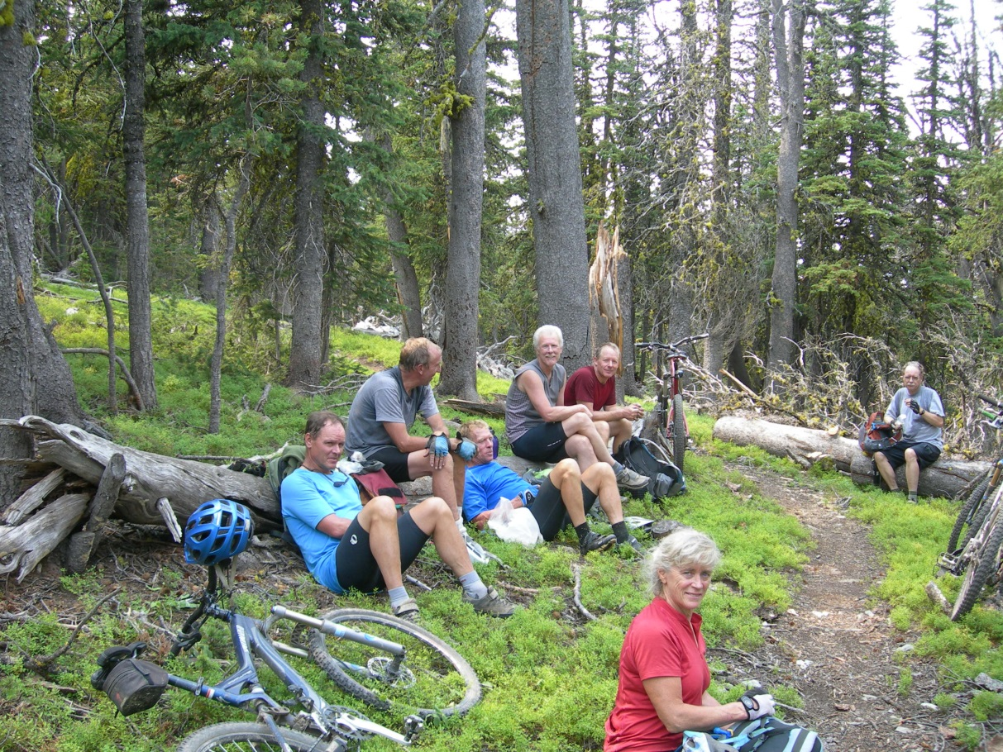
(Mt. Edith Trail. Photo credit: Greg Beardslee.)
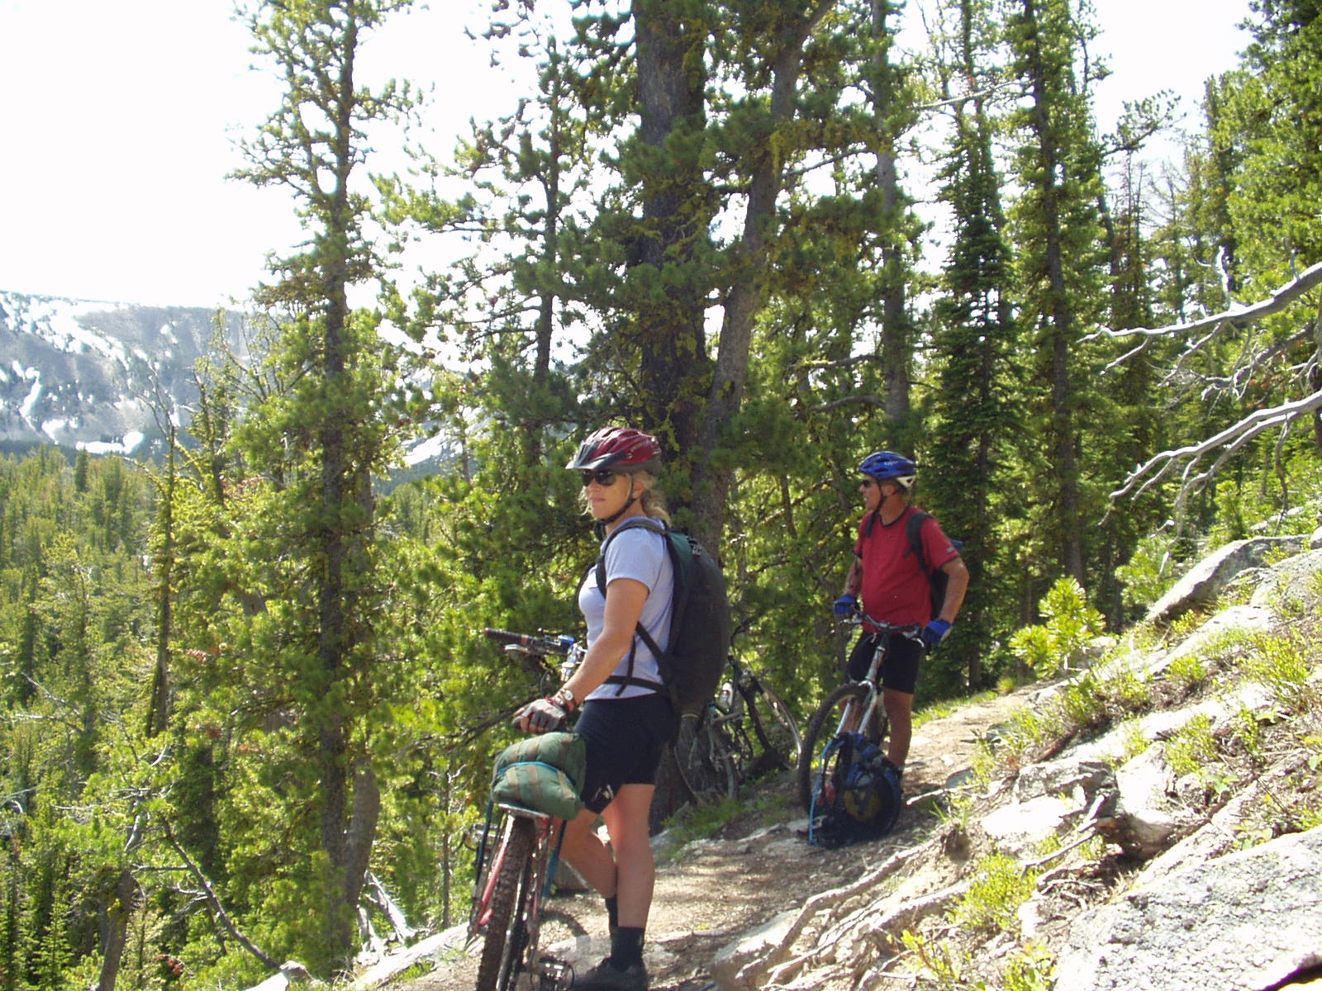
(Mt. Edith Trail. Photo credit: Greg Beardslee.)

I respectfully request consideration of the access to and use of these trails in the HLCNF’s evaluation of Polygon BB7. In addition, despite the wilderness characteristics present in Polygon BB7, I respectfully request that the HLCNF consider designating and managing Polygon BB7 as a National Recreation Area. By administratively designating Polygon BB7 as a National Recreation Area, it would allow the area to be managed with an emphasis on its outstanding recreational attributes occurring in its natural condition. See 36 C.F.R. § 294.1 (2016). In particular, the HLCNF could maintain Polygon BB7’s wildlife and wilderness characteristics, while at the same time specifically permitting the continued use of semi-primitive non-motorized recreation.

- Big Belts #8 – Polygon BB8
- Existing mountain biking trails within BB8

I respectfully request that Big Belts Polygon BB8 is not recommended for a wilderness area because of the following roads and trails that would be closed for mountain biking use:

Trail/Road Polygon #
Cedar Bar Trail #105 BB8
Carl Creek Trail #123 BB8

- Areas for mountain bike trail expansion within BB8

As a result of the ever-increasing popularity of mountain biking in the Helena area, described supra, there is a corresponding need to relieve congestion on existing trails open to mountain biking. In addition to its existing roads and trails, the BB8 Polygon represents an area where semi-primitive nonmotorized trails could be built and maintained in the future. Doing so would alleviate some of the pressures on the already existing trails and further support the multi-use management goals required under MUSY and NFMA. However, in the event that the BB8 Polygon was recommended for inclusion in the NWPS, such action would forever prevent mountain bikers from using those lands and would similarly prevent “sufficient latitude for periodic adjustments in use to conform to changing needs and conditions.” 16 U.S.C. § 531(a). I therefore respectfully request that the BB8 Polygon is not carried forward for NEPA analysis.

- Wilderness attributes of BB8

Because Polygon BB8 does not contain sufficient wilderness characteristics, I respectfully request that it is not included for further wilderness evaluation. As the South Belts Travel Plan even acknowledges:

The impact from human activity is noticeable. Users are seldom outside hearing distance of vehicles on Highway 12 or Forest roads that encompass this roadless area, or from the sights of residential development in the adjacent subdivision. . . .

A new subdivision occurs directly east of this roadless area, with numerous homes built since 1986. Two microwave towers are located on the ridge north of Grassy Mountain, nearby timber harvest units, livestock fencing and water developments are easily visible by users and distract from the natural appearance. The 10 kv powerline to the south is also obvious from elevations within this roadless area. . . .

The small size, shape and location of this roadless area limit opportunities for remoteness. Though users can generally avoid close contact with people during the winter and spring, as compared with the more busy summer and fall period, they still have little chance to avoid the sounds and sights from nearby developed areas. . . .

The openness of the topography in the center of this roadless area, its relatively small size, the presence of a paved State highway on the north side, and the encroaching residential development are problematic for managing this area for roadless characteristics.

(South Belts Travel Plan: Appendix C, at 129-31 (Nov. 2007) (emphasis added).)

Castles Wilderness Evaluation Inventory

“The Castles GA is an island mountain range east of White Sulphur Springs in Meagher County. The Castle’s forested higher elevations are surrounded by lower elevations that are predominantly treeless, instilling an island appearance.” (HLCNF Draft Desired Conditions, at 56 (Nov. 2015).) “Recreation provides large benefits to [Meagher] county. . . OHV use is common in the area and recent Forest Service and BLM closures are a source of frustration for some recreationists.” (HLCNF Roads Analysis Report, at 19 (2004) (emphasis added).)

“The recreation opportunities in the Castles primarily consist of trails that allow for year-round motorized access; two small campgrounds, one developed and one primitive, that provide overnight camping opportunities; and unique geologic formations that provide for interesting hiking and exploring. Nonmotorized access to the Castles is limited.” (HLCNF Draft Desired Conditions, at 56 (Nov. 2015).)

I respectfully request that the Castles wilderness inventory areas are not included for further NEPA evaluation in order to preserve its access for semi-primitive nonmotorized recreation.

Crazies Wilderness Evaluation Inventory

“The Crazies GA encompasses the northern portion of the Crazy Mountains. The southern portion of the GA is administered by the Gallatin National Forest. The GA is at the junction of Meagher, Wheatland, Sweet Grass, and Park counties. White Sulphur Springs is the nearest population center.” (HLCNF Draft Desired Conditions, at 57 (Nov. 2015).) “Recreation provides large benefits to [Meagher] county. . . OHV use is common in the area and recent Forest Service and BLM closures are a source of frustration for some recreationists.” (HLCNF Roads Analysis Report, at 19 (2004) (emphasis added).)

I respectfully request that the Crazies wilderness inventory areas are not included for further NEPA evaluation in order to preserve its access for semi-primitive nonmotorized recreation.

Divide Wilderness Evaluation Inventory

“This GA is the scenic backdrop and primary recreational resource for Montana’s capital city of Helena. It also includes the smaller communities of Austin, Rimini, Elliston, and Unionville. Portions of the GA are within Lewis and Clark, Powell, and Jefferson counties.” (HLCNF Draft Desired Conditions, at 58 (Nov. 2015).)

“Recreation opportunities appear to be a key factor in the ability of [Lewis & Clark] county to attract new businesses.” (HLCNF Roads Analysis Report, at 18 (2004) (emphasis added).) “Dependence upon wildlands for income [in Jefferson County] dropped to 33.25% and recreation and viewshed have become more economically important uses of National Forest than timber extraction. Mining operations have shrunk and timber harvest has declined to almost nothing. [Jefferson] county is looking more towards recreation and tourism as possibilities to expand their economy.” Id. (emphasis added). “In 1997 [Powell] county had the lowest per capita income of the 5 counties covered by the Helena National Forest. In addition to Government, [Powell] county economy is based upon ranching, timber and recreation.” Id., at 19 (emphasis added).

As previously indicated, Helena, Montana – the Divide’s nearest population center – has become a destination for mountain biking over the past decades. For example, in 2013, the Helena Tourism Alliance launched Bike Helena in an effort to brand Helena as a biking destination. See Madison, Helena Makes its Mark as a Mountain-Biking Destination, supra. Helena is also now recognized as a silver-level riding center destination by the IMBA. See id. IMBA’s silver-level designation earned Helena and the HLCNF recognition in mountain-biking magazines, on websites and on top mountain-bike destination lists.

The ever-increasing popularity of mountain biking in general, and specifically in the Helena area, has resulted in growing numbers of mountain bikers flocking to ride HLCNF’s trails. In turn, this has resulted in growing congestion and use on the already existing trails that are open to this semi-primitive nonmotorized ROS class. It is therefore necessary that the surrounding areas – including the Divide GA – remain open for trail expansion and semi-primitive nonmotorized use in the future. A large percentage of HLCNF lands are currently preserved for their wilderness characteristics due to their wilderness designations. However, were the HLCNF to expand the NWPS by including certain lands within the Divide GA, such actions would forever prevent and preclude mountain bikers from ever using those lands. Accordingly, I respectfully request that the HLCNF consider these impacts in its evaluation of wilderness inventory areas, and further, that the HLCNF neither carries forward nor includes the following areas for NEPA analysis to the extent I have specifically requested herein.

- Divide #2 – Polygon D2
- Existing mountain biking trails within D2

I respectfully request that Divide Polygon D2 is not recommended for a wilderness area because of the following roads and trails that would be closed for mountain biking use:

Trail/Road Polygon #
Priest Pass to Mullan Pass Trail D2
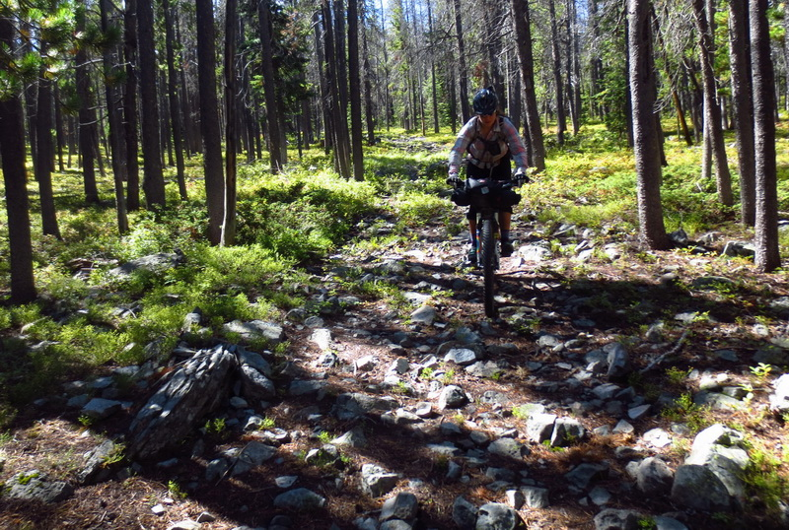
(CDNST in Polygon D2. Photo credit: Scott Morris.)

- Areas for mountain bike trail expansion within D2

The Continental Divide National Scenic Trail (“CDNST”) must be managed according to the National Trails Act, the CDNST Study Reports and Final Environmental Impact Statement, and the CDNST Comprehensive Plan (as amended) for the purpose of providing: “A continuous, appealing trail route, designed for the hiker and horseman, but compatible with other land uses.” (HLCNF Forest Plan Assessment, Ch. 8, Existing Designated Areas, at 16 (emphasis added).) I respectfully request that the HLCNF recognize that another compatible and established use on the CDNST is mountain biking. Please do not include Polygon D2 as a wilderness area because it would result in preventing mountain bike use on the CDNST through this section.

As a result of the ever-increasing popularity of mountain biking in the Helena area, described supra, there is a corresponding need to relieve congestion on existing trails open to mountain biking. In addition to its existing roads and trails, the D2 Polygon represents an area where semi-primitive nonmotorized trails could be built and maintained in the future. Doing so would alleviate some of the pressures on the already existing trails and further support the multi-use management goals required under MUSY and NFMA. However, in the event that the D2 Polygon was recommended for inclusion in the NWPS, such action would forever prevent mountain bikers from using those lands and would similarly prevent “sufficient latitude for periodic adjustments in use to conform to changing needs and conditions.” 16 U.S.C. § 531(a). I therefore respectfully request that the D2 Polygon is not carried forward for NEPA analysis.

- Wilderness attributes of D2

Because Polygon D2 does not contain sufficient wilderness characteristics, I respectfully request that it is not included for further wilderness evaluation. As the Divide Travel Plan’s Final Environmental Impact Statement even acknowledges:

The impacts of human activity are present in much of the area. Past mining has created access roads throughout the area. . . . The Continental Divide splits the area – creating most of the topographic screening. People traveling along the higher open ridges on the north end can see human activities and development within the area or adjacent areas.

(Divide Travel Plan: FEIS, at 83 (Apr. 2015) (emphasis added).)

- Divide #3 – Polygon D3
- Existing mountain biking trails within D3

The HLCNF should recognize that the following roads and trails have been used by and are currently available for mountain biking within Polygon D3:

Trail/Road Polygon #
Bison-Blackfoot Trail #328 D3
Blackfoot Meadows Trail #329 D3
Continental Divide Trail #337 D3
Larabee Gulch Trail #359 D3
Monarch Creek Trail #362 D3

I respectfully request consideration of the access to and use of these trails in the HLCNF’s evaluation of Polygon D3.

- Mountain bike trail consideration within D3

The CDNST must be managed according to the National Trails Act, the CDNST Study Reports and Final Environmental Impact Statement, and the CDNST Comprehensive Plan (as amended) for the purpose of providing: “A continuous, appealing trail route, designed for the hiker and horseman, but compatible with other land uses.” (HLCNF Forest Plan Assessment, Ch. 8, Existing Designated Areas, at 16 (emphasis added).) I respectfully request that the HLCNF recognize that another compatible and existing use on the CDNST is mountain biking.

Although Polygon D3 is currently managed as a Recommended Wilderness Area, I respectfully request the HLCNF also consider the possibility of designating and managing Polygon D3 as a National Recreation Area. By administratively designating Polygon D3 as a National Recreation Area, it would allow the area to be managed with an emphasis on its outstanding recreational attributes occurring in its natural condition. See 36 C.F.R. § 294.1 (2016). In particular, the HLCNF could maintain Polygon D3’s wildlife and wilderness characteristics, while at the same time specifically permitting the continued use of semi-primitive non-motorized recreation.

- Divide #5 – Polygon D5
- Existing mountain biking trails within D5

The D5 WIA is approximately 10 air miles southwest of Helena, Montana in Lewis & Clark County. The northern boundary runs adjacent to private land in Colorado Gulch. The west side of this area is easily accessible off the Rimini Road #695 and the east side is accessible from a county road.

The HLCNF should recognize that the following roads and trails have been used by and are currently available for mountain biking within Polygon D5:

Trail/Road Polygon #
Former road #578 (Travis Cr. to Chessman Road) D5
Former road #4177 (To top of Colorado Mountain) D5

I respectfully request consideration of the access to and use of these trails in the HLCNF’s evaluation of Polygon D5.

- Mountain bike trail consideration within D5

Due to ever-increasing trail use and congestion in the Helena South Hills, Polygon D5 should be viewed as an obvious and suitable area to expand that trail system and alleviate some of the user pressure placed on it. This section of public land may also serve as an important corridor between the CDNST and the Helena South Hills trail system in future travel plans.

In addition, I respectfully request that the HLCNF also consider the possibility of designating and managing Polygon D5 as a National Recreation Area. By administratively designating Polygon D5 as a National Recreation Area, it would allow the area to be managed with an emphasis on its outstanding recreational attributes occurring in its natural condition. See 36 C.F.R. § 294.1 (2016). In particular, the HLCNF could maintain Polygon D5’s wildlife and wilderness characteristics, while at the same time specifically permitting the continued use of semi-primitive non-motorized recreation.

- Divide #13 – Polygon D13
- Existing mountain biking trails within D13

I respectfully request that Divide Polygon D13 is not recommended for a wilderness area because of the following roads and trails that would be closed for mountain biking use:

Trail/Road Polygon #
Continental Divide Trail #337 to Priest Pass D13

- Areas for mountain bike trail expansion within D13

The CDNST must be managed according to the National Trails Act, the CDNST Study Reports and Final Environmental Impact Statement, and the CDNST Comprehensive Plan (as amended) for the purpose of providing: “A continuous, appealing trail route, designed for the hiker and horseman, but compatible with other land uses.” (HLCNF Forest Plan Assessment, Ch. 8, Existing Designated Areas, at 16 (emphasis added).) I respectfully request that the HLCNF recognize that another compatible and existing use on the CDNST is mountain biking. Please do not include Polygon D13 as a wilderness area because it would result in preventing mountain bike use on the CDNST through this section.

As a result of the ever-increasing popularity of mountain biking in the Helena area, described supra, there is a corresponding need to relieve congestion on existing trails open to mountain biking. In addition to its existing roads and trails, the D13 Polygon represents an area where semi-primitive nonmotorized trails could be built and maintained in the future. Doing so would alleviate some of the pressures on the already existing trails and further support the multi-use management goals required under MUSY and NFMA. However, in the event that the D13 Polygon was recommended for inclusion in the NWPS, such action would forever prevent mountain bikers from using those lands and would similarly prevent “sufficient latitude for periodic adjustments in use to conform to changing needs and conditions.” 16 U.S.C. § 531(a). I therefore respectfully request that the D13 Polygon is not carried forward for NEPA analysis.

- Wilderness attributes of D13

Because Polygon D13 does not contain sufficient wilderness characteristics, I respectfully request that it is not included for further wilderness evaluation. As the Divide Travel Plan’s Final Environmental Impact Statement even acknowledges:

The impacts of human activity are present in much of the area. Past mining has created access roads throughout the area. . . . The Continental Divide splits the area – creating most of the topographic screening. People traveling along the higher open ridges on the north end can see human activities and development within the area or adjacent areas.

(Divide Travel Plan: FEIS, at 83 (Apr. 2015) (emphasis added).)

Of important note is that D13 is also adjacent to a superfund cleanup site. The superfund cleanup site will eliminate any possibility of solitude during the cleaning process. If any superfund activities commence, cleanup activities, likely to include heavy machinery moving along the southern border of D13, would occur for many years.

Elkhorns Wilderness Evaluation Inventory

“The Elkhorns GA encompasses the Elkhorn Mountains in Broadwater and Jefferson counties and includes the small mining town of Elkhorn. The nearest large population center is Helena, Montana. Many smaller communities also have intimate relationships with the GA: Montana City, Clancy, Alhambra, Jefferson City, Boulder, Radersburg, Townsend, Winston, and East Helena.” (HLCNF Draft Desired Conditions, at 60 (Nov. 2015).)

“The economy of [Broadwater] county has traditionally been based upon on agriculture and logging. Currently both of these industries are in a slump and the county’s economy is depressed. . . . The communities [within Broadwater County] are looking more towards recreation related industries to provide additional income to the communities.” (HLCNF Roads Analysis Report, at 18 (2004) (emphasis added).) “Dependence upon wildlands for income [in Jefferson County] dropped to 33.25% and recreation and viewshed have become more economically important uses of National Forest than timber extraction. Mining operations have shrunk and timber harvest has declined to almost nothing. [Jefferson] county is looking more towards recreation and tourism as possibilities to expand their economy.” Id. (emphasis added).

The history of the Elkhorns status of wilderness and inclusion as a Wildlife Management Unit was summarized by the HLCNF’s Forest Plan Assessment:

The Montana Wilderness Study Act (Public Law 95-150) identified the Elkhorn Mountain range as needing “additional study” for its potential inclusion in the National Wilderness Preservation System. Before the Montana Wilderness Study Act was finalized in 1977, and after considerable public input and hearings, Congressman John Melcher separated the Elkhorns out of the act and introduced similar but separate legislation that established an individual wilderness study area for the Elkhorns. By enacting Public Law 94-557 in 1976, Congress directed the Forest Service to evaluate approximately 77,346 acres of the Elkhorns for possible inclusion in the National Wilderness Preservation System.

Between 1977 and 1981, the Elkhorns Wilderness Study Area was analyzed to determine its inclusion into the National Wilderness Preservation System. There was high public interest in the analysis that was conducted, and much criticism from both the conservation and multiple use communities. Finally, on November 24, 1981, chief of the Forest Service, R. Max Peterson, signed a record of decision based on the analysis in the Final Environmental Impact Statement. The record of decision states, “It is my decision to recommend that the Elkhorn Wilderness Study Area not be designated wilderness. Direction will be developed for the Helena and Deerlodge Forest Plans to establish a management unit which emphasizes the very high wildlife values.” All 160,000 acres of Forest System lands within the Elkhorn Mountain Range were administratively designated as a wildlife management unit.

In 1982, President Reagan transmitted to congress his concurrence with the Secretary of Agriculture (John Block) that the Elkhorns were not suitable for inclusion in the National Wilderness Preservation System. Congress had four years to consider that recommendation and act on it, and if not, the recommendation would be automatically implemented. During that 4-year period, the Forest Service was to continue managing the study area to maintain its wilderness potential. By 1986, in the four years, congress did not act on the President’s recommendation, which automatically implemented the recommendation and released the Forest Service from its mandate to maintain the area under the designation as a wilderness study area.

(HLCNF Forest Plan Assessment, Ch. 8, Existing Designated Areas, at 11 (emphasis added).)

“There are numerous trailheads and dispersed recreation opportunities throughout the Elkhorns, including a number of dispersed nonmotorized trails and primitive camping areas.” (HLCNF Draft Desired Conditions, at 61 (Nov. 2015).) “Recreation in the Elkhorns emphasizes its unique resources including . . . a well-defined and managed transportation system which offers opportunities for both non-motorized and motorized recreational activities.” (HLCNF Forest Plan Amendment No. 15, at 2 (March 6, 2000 (emphasis added).)

One of the stated guidelines for Forest Plan management within the Elkhorns GA is to “Provide specific opportunities to enhance the safety and enjoyment of non-motorized recreational users, including 10-20 miles of marked cross-county ski and mountain bike trails, and permitted wildlife viewing guided trips.” (HLCNF Forest Plan Amendment No. 15, at 12 (March 6, 2000 (emphasis added).) In fact, one of the stated goals for the non-motorized areas within the Elkhorns is to provide “a variety of semi-primitive and primitive nonmotorized recreation opportunities within the context of a healthy, diverse ecosystem.” Id., at 20 (emphasis added). The Forest Service has even produced a mountain biking map of the Elkhorns.

As previously indicated, Helena, Montana – the Elkhorn’s nearest population center – has become a destination for mountain biking over the past decades. For example, in 2013, the Helena Tourism Alliance launched Bike Helena in an effort to brand Helena as a biking destination. See Madison, Helena Makes its Mark as a Mountain-Biking Destination, supra. Helena is also now recognized as a silver-level riding center destination by the IMBA. See id. IMBA’s silver-level designation earned Helena and the HLCNF recognition in mountain-biking magazines, on websites and on top mountain-bike destination lists.

The ever-increasing popularity of mountain biking in general, and specifically in the Helena area, has resulted in growing numbers of mountain bikers flocking to ride HLCNF’s trails. In turn, this has resulted in growing congestion and use on the already existing trails that are open to this semi-primitive nonmotorized ROS class. It is therefore necessary that the surrounding areas – including the Elkhorns – remain open for trail expansion and semi-primitive nonmotorized use in the future. A large percentage of HLCNF lands are currently preserved for their wilderness characteristics due to their wilderness designations. However, were the HLCNF to expand the NWPS by including certain lands within the Elkhorns, such actions would forever prevent and preclude mountain bikers from ever using those lands. Accordingly, I respectfully request that the HLCNF consider these impacts in its evaluation of wilderness inventory areas, and further, that the HLCNF neither carry forward nor include the following areas for NEPA analysis as potential recommendations for inclusion in the NWPS.

- Elkhorns #1 – Polygon E1
- Existing mountain biking trails within E1

I respectfully request that Elkhorns Polygon E1 is not recommended for a wilderness area because of the following roads and trails that would be closed for mountain biking use:

Trail/Road Polygon #
Casey Meadows #343 E1
Pinecrest Trail E1
McClellan Creek Trail #294 E1
S. Fork Crow Creek Trail #277 E1
Crow Creek Trail #424 E1
Beaver Creek #115 E1
Longfellow Park Area #112, 133, 138, 135 E1
Sheep Park #116 E1

- Areas for mountain bike trail expansion within E1.

As a result of the ever-increasing popularity of mountain biking in the Helena area, described supra, there is a corresponding need to relieve congestion on existing trails open to mountain biking. In addition to its existing roads and trails, the E1 Polygon represents an area where semi-primitive nonmotorized trails could be expanded and maintained in the future. Doing so would alleviate some of the pressures on the already existing trails and further support the multi-use management goals required under MUSY and NFMA. However, in the event that the E1 Polygon was recommended for inclusion in the NWPS, such action would forever prevent mountain bikers from using those lands and would similarly prevent “sufficient latitude for periodic adjustments in use to conform to changing needs and conditions.” 16 U.S.C. § 531(a). I therefore respectfully request that the E1 Polygon is not carried forward for NEPA analysis.

- Wilderness attributes of E1.

“The landscapes and the vegetation of the Elkhorn Mountain range have been significantly altered by historic placer and lode mining, free range grazing, and recreation. . . . These influences have had serious and lasting impact on the natural resources of the area[.]” (HLCNF Forest Plan Assessment, Ch. 8, Existing Designated Areas, at 12 (emphasis added).) Polygon E1 is also subjected to regular, low-altitude aircraft traffic flying in and out of the Helena Regional Airport. Because Polygon E1 does not contain sufficient wilderness characteristics, I respectfully request that it is not included for further wilderness evaluation.

- Elkhorns #3 – Polygon E3
- Existing mountain biking trails within E3

I respectfully request that Elkhorns Polygon E3 is not recommended for a wilderness area because of the following roads and trails that would be closed for mountain biking use:

Trail/Road Polygon #
Muskrat Creek Trail #441 / 72 / 111 E3

In its wilderness evaluation, the HLCNF should take into account that the Muskrat Creek Trail is one of the most popular destination mountain bike rides in the state of Montana.
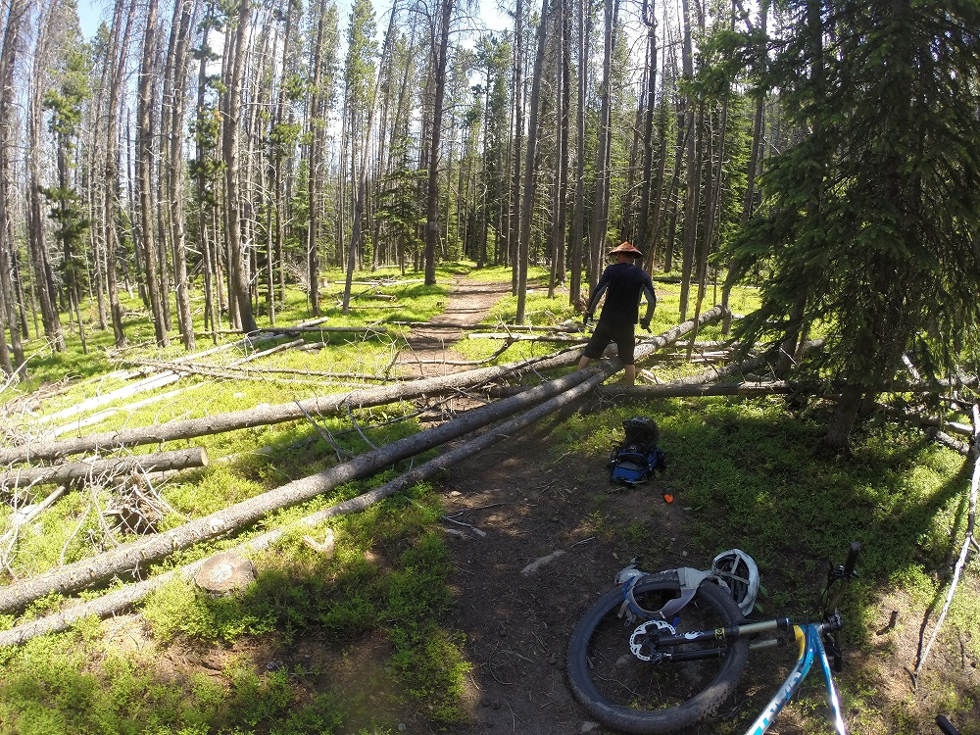
(Muskrat Creek Trail. Photo credit: Jared Steffen.)

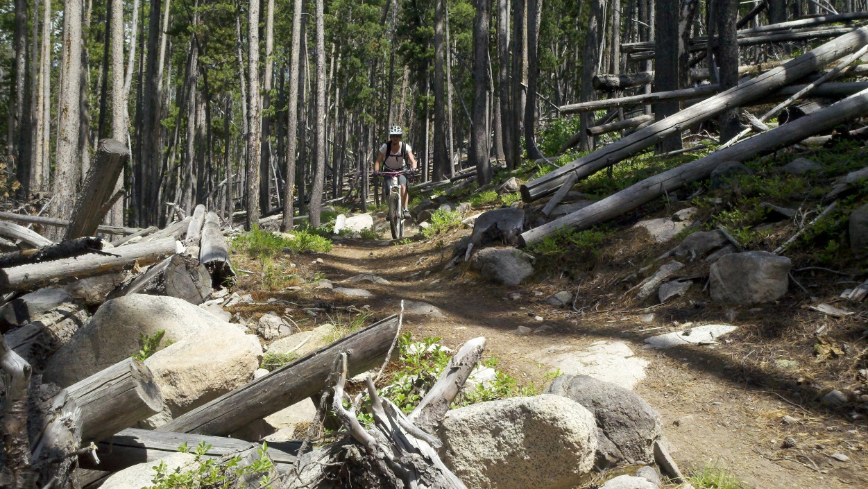
(Muskrat Creek Trail. Photo credit: Mike Williamson.)
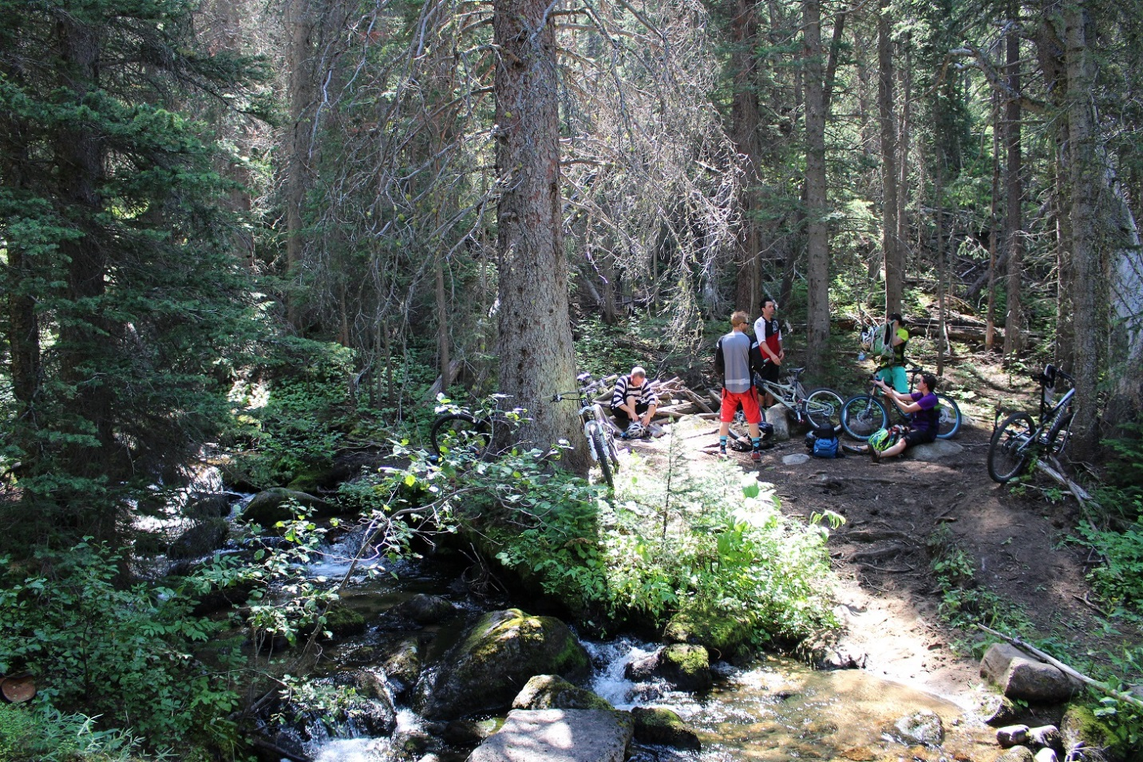
(Muskrat Creek Trail. Photo credit: Jared Steffen.)

- Areas for mountain bike trail expansion within E3

As a result of the ever-increasing popularity of mountain biking in the Helena area, described supra, there is a corresponding need to relieve congestion on existing trails open to mountain biking. In addition to its existing roads and trails, the E3 Polygon represents an area where semi-primitive nonmotorized trails could be built and maintained in the future. Doing so would alleviate some of the pressures on the already existing trails and further support the multi-use management goals required under MUSY and NFMA. However, in the event that the E3 Polygon was recommended for inclusion in the NWPS, such action would forever prevent mountain bikers from using those lands and would similarly prevent “sufficient latitude for periodic adjustments in use to conform to changing needs and conditions.” 16 U.S.C. § 531(a). I therefore respectfully request that the E1 Polygon is not carried forward for NEPA analysis.

- Wilderness attributes of E3

“The landscapes and the vegetation of the Elkhorn Mountain range have been significantly altered by historic placer and lode mining, free range grazing, and recreation. . . . These influences have had serious and lasting impact on the natural resources of the area[.]” (HLCNF Forest Plan Assessment, Ch. 8, Existing Designated Areas, at 12 (emphasis added).)

Further, Polygon E3 is surrounded by numerous 4WD tracks and roads also exist in this area, which extend from the town of Elkhorn. The northern and much of the eastern end of Polygon E3 are bordered by a 4WD track/road as well. The western end is all private land, and further, Polygon E3 is approximately 2.5 miles from Interstate 15. As such, opportunities for solitude will likely be difficult in this area. Further, Polygon E3 is subjected to regular, low-altitude aircraft traffic flying in and out of the Helena Regional Airport.

Because Polygon E3 does not contain sufficient wilderness characteristics, I respectfully request that it is not included for further wilderness evaluation.

Highwoods Wilderness Evaluation Inventory – Polygon H2

“The Highwoods GA is the smallest of the GAs within the plan area and encompasses the Highwood Mountains. This isolated island range is located within Cascade, Chouteau, and Judith Basin counties. This GA is the closest NFS land to Great Falls.” (HLCNF Draft Desired Conditions, at 62 (Nov. 2015).)

“Within the GA, there is one small developed campground, Thain Creek Campground, and a developed trailhead in North Fork Highwood Creek. These developed sites provide access points for the many single track trails that traverse the Highwoods. These trails are used extensively by motorcycle users as well as by hikers and horseback riders.” (HLCNF Draft Desired Conditions, at 63 (Nov. 2015).)

I respectfully request that Highwoods Polygon H2 is not recommended for a wilderness area because of the following roads and trails that would be closed for mountain biking use:

Trail/Road Polygon #
Thain Cr/Windy Mtn Trail #454 H2
Briggs Cr Trail #431 H2
Trail #412 H2
White Wolf Trail #413 H2
North Fork of Highwood Cr Trail #423 H2
Trail #415 H2
Trail #411 H2

Importantly, these trails were featured in a published mountain bike guide book, entitled: “Montana Singletrack.” See Will Robertson, Montana Singletrack: The Mountain Biker’s Guide to Montana (2007).
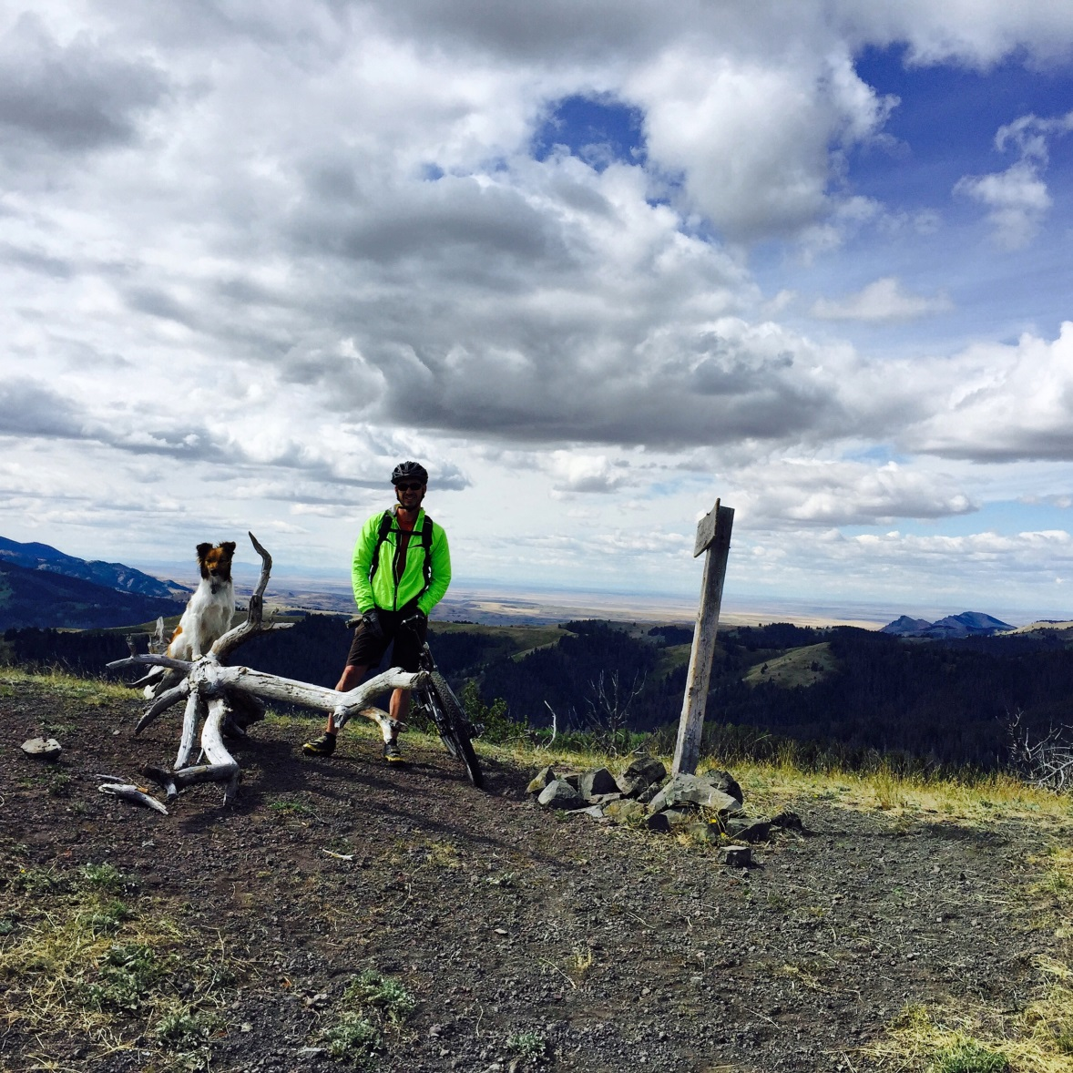
(Highwoods mountain biking. Photo credit: Brian Thompson.)

Little Belts Wilderness Evaluation Inventory

“The Little Belts GA is a large isolated mountain range in central Montana. It measures approximately 60 miles southeast to northeast and is 30 miles across. . . . Portions of this GA are located in Meagher, Judith Basin, Cascade, and Wheatland counties. It is surrounded by predominantly treeless foothills of prairie and sagebrush steppe. The city of Great Falls is 50 miles to its northwest, Stanford to the east, Harlowton to the southeast, and the town of White Sulphur Springs is on its southern edge. The Little Belts GA is bisected north-south by the Kings Hill scenic byway (US Highway 89), along which the small communities of Niehart and Monarch reside. Most of the Little Belts can be described as remote but accessible by a well-distributed transportation network.” (HLCNF Draft Desired Conditions, at 64 (Nov. 2015).) “Recreation provides large benefits to [Meagher] county. . . OHV use is common in the area and recent Forest Service and BLM closures are a source of frustration for some recreationists.” (HLCNF Roads Analysis Report, at 19 (2004) (emphasis added).)

“The Little Belts GA offers diverse recreation opportunities. This includes developed campgrounds; developed trailheads; recreation residences; Camp Rotary; Showdown ski area; King’s Hill winter recreation area that includes Silvercrest groomed cross-country ski area, snowmobile, snow shoe, and dog sled opportunities; cabin rentals; and interpretive panels. The Middle Fork Wilderness Study Act area is located within the center of the Little Belts Mountain range. This primitive area was identified in 1977 as important for its wilderness characteristics. Dispersed recreation activities include motorized and nonmotorized trails, snowmobile trails, caves, and dispersed camping. The Little Belts GA provides permitted access within the Smith River corridor.” (HLCNF Draft Desired Conditions, at 65 (Nov. 2015).)

- Little Belts #1 – Polygon LB1
I respectfully request that Little Belts Polygon LB1 is not recommended for a wilderness area because of the following roads and trails that would be closed for mountain biking use:

Trail/Road Polygon #
Deep Creek National Recreation Trail LB1

- Little Belts #2 – Polygon LB2
I respectfully request that Little Belts Polygon LB2 is not recommended as a wilderness area because of the following roads and trails that would be closed for mountain biking use:

Trail/Road Polygon #
Pilgrim Cr Trail #304 LB2

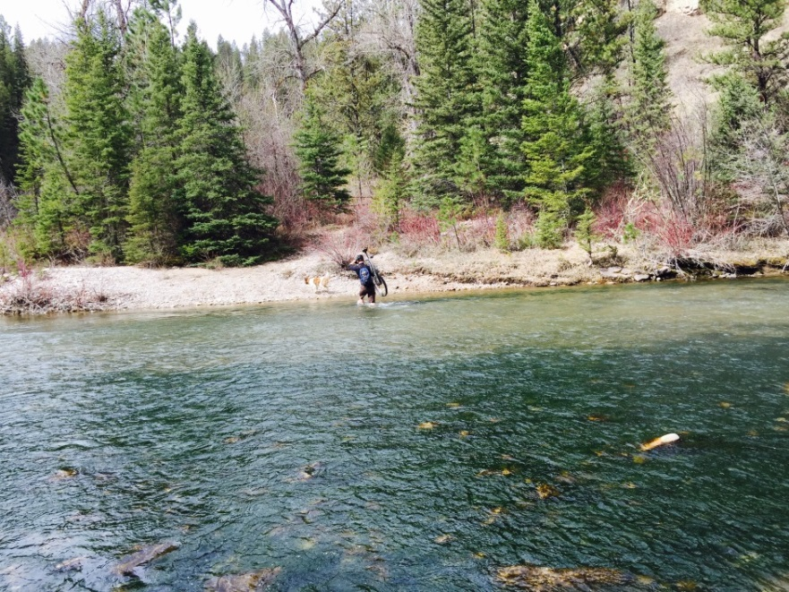
(Pilgrim Creek Trail #304. Photo credit: Brian Thompson.)

- Little Belts #8 – Polygon LB8
I respectfully request that Little Belts Polygon LB8 is not recommended as a wilderness area because of the following roads and trails that would be closed for mountain biking use:

Trail/Road Polygon #
Henn Gulch Rd LB8
Hoover Ridge Trail #736 LB8
Bender Cr Trail #731 LB8
Oti Park Cr Trail #732 LB8
Jefferson Cr Atv Trail LB8
Silver Gulch Trail #402 LB8
Dry Wolf Trail #401 LB8
Butcherknife Trail #417 LB8
Placer Creek Trail #419 LB8

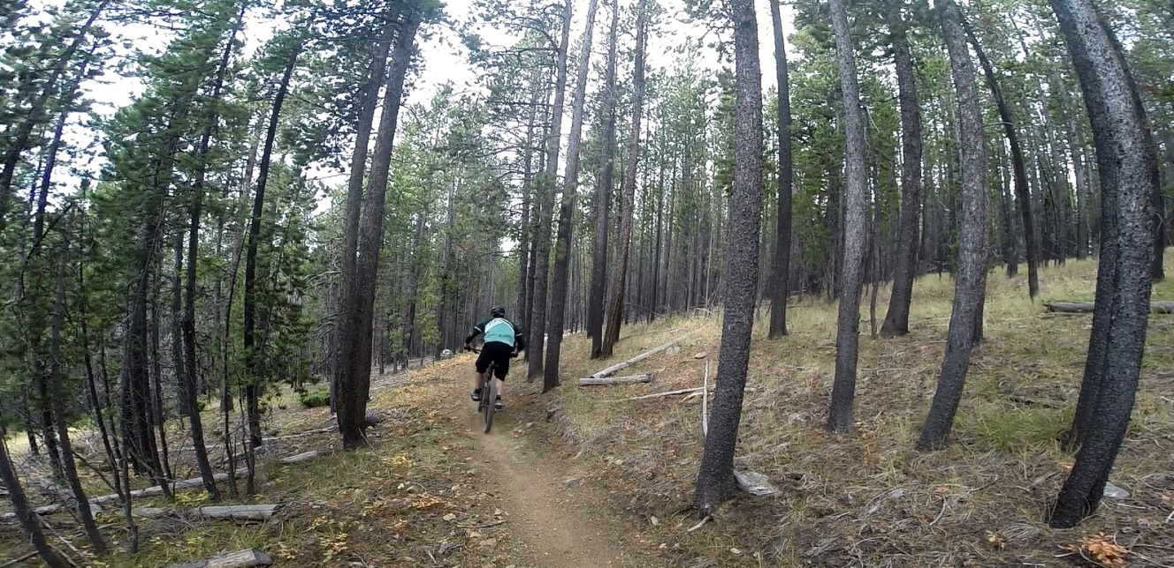
(Bender Creek Trail. Photo credit: Jared Steffen.)

- Little Belts #11 – Polygon LB11
I respectfully request that Little Belts Polygon LB11 is not recommended as a wilderness area because of the following roads and trails that would be closed for mountain biking use:

Trail/Road Polygon #
Calf Cr Trail #722/724/711 LB11

- Little Belts #16 – Polygon LB16
I respectfully request that Little Belts Polygon LB16 is not recommended as a wilderness area because of the following roads and trails that would be closed for mountain biking use:

Trail/Road Polygon #
Doerr Cr/Sand Point Trail #436/422/407 LB16

Rocky Mountain Range Wilderness Evaluation Inventory

“The Rocky Mountain Range GA is located in portions of Teton, Pondera, Glacier, and Lewis and Clark counties. The closest communities are Augusta, Choteau, Bynum, Dupuyer, East Glacier, and Heart Butte. Great Falls is the nearest large population center, about an hour drive to the southeast. The GA is bordered by U.S. Highway 2 and Glacier National Park to the north.” (HLCNF Draft Desired Conditions, at 66 (Nov. 2015).) “Recreation opportunities appear to be a key factor in the ability of [Lewis & Clark County] county to attract new businesses.” (HLCNF Roads Analysis Report, at 18 (2004) (emphasis added).)

“A large portion of the Rocky Mountain Range GA is designated wilderness and includes portions of the Scapegoat and Bob Marshall Wilderness Areas. These two wilderness areas are components of a greater wilderness complex that totals well over 1.5 million acres, the 5th largest wilderness area in the lower 48 states. With the passing of the National Defense Act of 2015 in December 2014, an additional 67,112 acres were added to these wilderness areas. The GA’s proximity to this wilderness complex, Glacier National Park, and adjacent wild areas of Canada make it a critical component of the Northern Continental Divide Ecosystem.” (HLCNF Draft Desired Conditions, at 67 (Nov. 2015) (emphasis added).) Despite the vast majority of the Rocky Mountain Range consisting of wilderness areas, there have been significant reductions in the Rocky Mountain District’s wilderness budget from $128,000 five years ago to $63,000 today. (Need to Change: Summary Report, at 21 (Oct. 15, 2015).) This reduction in the budget used for managing the already existing wilderness should be strongly considered as a significant management obstacle to adding any more wilderness in the Rocky Mountain Range DA.

- Rocky Mountain Range #1 – Polygon RM1

I respectfully request that Rocky Mountain Range Polygon #1 is not recommended as a wilderness area because of the cultural values and uses of RM1 (Badger-Two Medicine) are at odds with conventional Wilderness management. RM1 is arguably the wildest location in the lower 48 states where mountain bike use is allowed. Mountain bike use is a quiet muscle powered activity that is not at odds with wilderness values but is not presently allowed in designated Wilderness. RM1 has been managed in the past by bicycle patrol, and could be managed in the future that way as well. An essential tool for traverse of RM1 is a chain saw. Bicyclists transport chainsaws by using specially designed carrying racks. For instance, bicyclists from Montana Mountain Bike Alliance regularly team with Montana Backcountry Horsemen to clear backcountry trails of deadfall. Tribal members could use these same smart techniques to keep RM1 accessible. For these reasons, I recommend that the Badger-Two Medicine area, including portions of RM1, be recommended not as wilderness, but as a Traditional Cultural District, with recreation management continuing unchanged.

- Rocky Mountain Range #2 – Polygon RM2

I respectfully request that Rocky Mountain Range Polygon RM2 is not recommended as a wilderness area because of the following roads and trails that would be closed for mountain biking use:

Trail/Road Polygon #
Clary Coulee Trail #177 RM2

- Rocky Mountain Range #3 – Polygon RM3

I respectfully request that Rocky Mountain Range Polygon RM3 is not recommended as a wilderness area because all of the roads and trails – both existing and for potential future expansion – that would be closed for mountain biking. This is an area with high recreational value and is subject to the wilderness and trail considerations identified in subsection 6, infra.

- Rocky Mountain Range #4 – Polygon RM4

I respectfully request that Rocky Mountain Range Polygon RM4 is not recommended as a wilderness area because all of the roads and trails – both existing and for potential future expansion – that would be closed for mountain biking. This is an area with high recreational value and is subject to the wilderness and trail considerations identified in subsection 6, infra.

- Rocky Mountain Range #5 – Polygon RM5

I respectfully request that Rocky Mountain Range Polygon RM5 is not recommended as a wilderness area because all of the roads and trails – both existing and for potential future expansion – that would be closed for mountain biking. This is an area with high recreational value and is subject to the wilderness and trail considerations identified in subsection 6, infra.

- Wilderness & trail considerations in the Rocky Mountain Range – Polygons RM1 through RM5

The Rocky Mountain Front Heritage Act of 2013 contains language directing land managers to work with “interested parties” – that is, mountain bike advocacy groups – to identify new bicycling opportunities outside of the Wilderness portions of the area: “Not later than 2 years after the date of enactment of this Act, the Secretary of Agriculture, in consultation with interested parties, shall conduct a study to improve nonmotorized recreation trail opportunities (including mountain bicycling) on land not designated as wilderness within the district.” Rocky Mountain Front Heritage Act, § 7 (emphasis added). Accordingly, mountain bikers are statutorily afforded the opportunity to participate in a forum that will encourage communication and ideas to be brought forward. Several areas along the Rocky Mountain Range, both north and south of Deep Creek, are desirable for trail loops that mountain bikers would enjoy. Even thoughtful new trail connectors could be used to create longer loops that incorporate older existing trails. Rugged areas of the Rocky Mountain Range are spectacular and beautiful, and every area outside of Wilderness, no matter how rugged, should be considered to “improve nonmotorized recreation trail opportunities.” Id. Cyclists would greatly appreciate the opportunity to enjoy the full spectrum of recreational opportunities – including maintaining and even expanding the current levels of semi-primitive nonmotorized access – to all non-NWPS lands in the Rocky Mountain Range. These basic considerations should preclude RM1 through RM5 from being included for further NEPA wilderness evaluation.

Snowies Wilderness Evaluation Inventory – Polygon S1

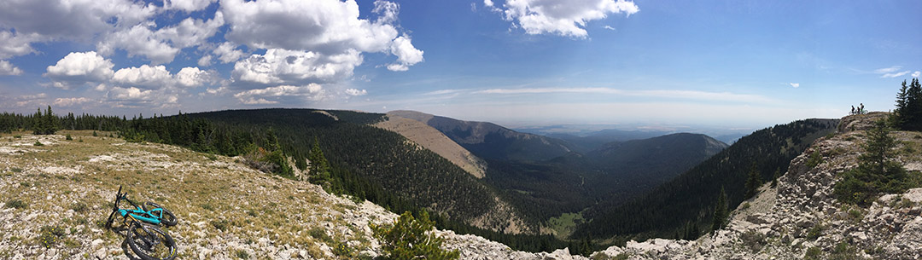
(Snowies mountain biking. Photo credit: The Dirt Concern)

“The Snowies is the farthest east GA within the HLC NFs plan area. This remote GA is primarily in Fergus County with smaller portions in Golden Valley County. Lewistown is the largest nearby population center.” (HLCNF Draft Desired Conditions, at 70 (Nov. 2015).)

“The Big Snowies Wilderness Study Act area is approximately 87,968 acres and is located within the center of the Big Snowy mountain range. This undeveloped area is managed to preserve opportunities for inclusion in the National Wilderness Preservation System and includes opportunities for a more primitive recreation experience.” (HLCNF Draft Desired Conditions, at 71 (Nov. 2015).)

I respectfully request that Snowies Polygon S1 is not recommended as a wilderness area because of the following roads and trails that would be closed for mountain biking use:

Trail/Road Polygon #
Crystal lake Loop Trail #493/445A/445 S1
Snowy Mountain Crest/Uhlhorn Trail #490/493 S1
Old Baldy Trail #650 S1

Importantly, these trails were featured in a published mountain bike guide book, entitled: “Montana Singletrack.” See Will Robertson, Montana Singletrack: The Mountain Biker’s Guide to Montana (2007).

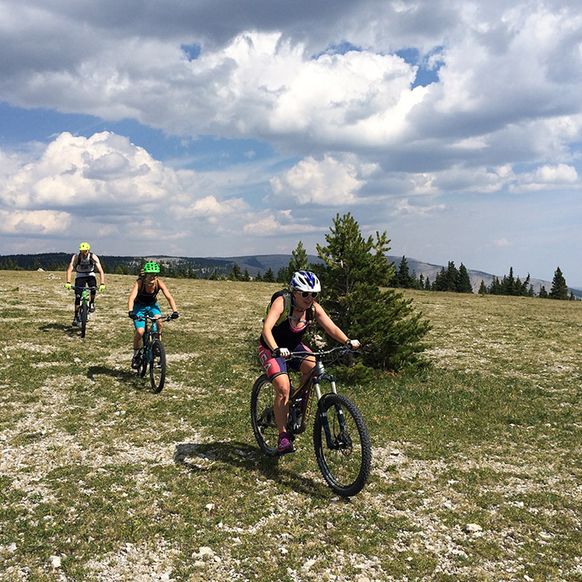
(Snowies mountain biking. Photo credit: The Dirt Concern)

Upper Blackfoot Wilderness Evaluation Inventory

“The Upper Blackfoot GA spans Lewis & Clark and Powell counties. The towns of Lincoln and Helmville are the nearest communities.” (HLCNF Draft Desired Conditions, at 72 (Nov. 2015).) “Recreation opportunities appear to be a key factor in the ability of [Lewis & Clark County] county to attract new businesses.” (HLCNF Roads Analysis Report, at 18 (2004) (emphasis added).) “In 1997 [Powell] county had the lowest per capita income of the 5 counties covered by the Helena National Forest. In addition to Government, [Powell] county economy is based upon ranching, timber and recreation.” Id., at 19 (emphasis added).

“Recreation use in the Upper Blackfoot GA varies by location. The northern area includes the south part of the Scapegoat Wilderness, and recreation activities such as backpacking, horseback riding, and outfitter guiding take place across these landscape. There are a few developed recreation sites within the GA including a couple of campgrounds and a few larger developed trailheads. Additionally, there is dispersed recreation use with both motorized and nonmotorized trails and dispersed camping in many of the stream bottoms. Snowmobiling and dog sledding are the primary winter activities.” (HLCNF Draft Desired Conditions, at 73 (Nov. 2015).)

A large percentage of HLCNF lands are currently preserved for their wilderness characteristics due to their wilderness designations. However, were the HLCNF to expand the NWPS by including certain lands within the Upper Blackfoot GA, such actions would forever prevent and preclude mountain bikers from ever using those lands. Accordingly, I respectfully request that the HLCNF consider these impacts in its evaluation of wilderness inventory areas, and further, that the HLCNF neither carries forward nor includes the following areas for NEPA analysis to the extent I have specifically requested herein.

- Upper Blackfoot #1 – Polygon UB1

- Existing mountain bike trails and roads within UB1
The Alice Creek Trail and CDNST from Lewis and Clark Pass to Alice Mountain in this area are very important destination trails for people seeking backcountry bicycle rides; in particular, for mountain bikers coming from the closer population centers of Missoula, Helena, and Great Falls.

The HLCNF should recognize that the following roads and trails have been used by and are currently available for mountain biking within Polygon UB1:

Trail/Road Polygon #
Alice Creek Trail/Road #490 UB1
Lewis and Clark Pass Trail #493 UB1
Silver King Mountain Trail #420 UB1
Continental Divide National Scenic Trail #440 UB1

The following map demonstrates some of these trails that are currently open to mountain biking in Polygon UB1. I respectfully request consideration of the access to and use of these trails in the HLCNF’s evaluation of Polygon UB1.

- Areas for mountain bike expansion within UB1

While I have no personal knowledge of whether or not there are plans to increase the current trails in UB1, the remoteness and experience of solitude for people riding bicycles in this area is important. The individuals who ride bicycles in this area value and help maintain these trails for all non-motorized users and, if given the opportunity, will continue to be great partners in the future.

Moreover, the CDNST must be managed according to the National Trails Act, the CDNST Study Reports and Final Environmental Impact Statement, and the CDNST Comprehensive Plan (as amended) for the purpose of providing: “A continuous, appealing trail route, designed for the hiker and horseman, but compatible with other land uses.” (HLCNF Forest Plan Assessment, Ch. 8, Existing Designated Areas, at 16 (emphasis added).) I respectfully request that the HLCNF recognize that another compatible and existing use on the CDNST is mountain biking.

In addition, I respectfully request the HLCNF also consider the possibility of designating and managing Polygon UB1 as a National Recreation Area. By administratively designating Polygon UB1 as a National Recreation Area, it would allow the area to be managed with an emphasis on its outstanding recreational attributes occurring in its natural condition. See 36 C.F.R. § 294.1 (2016). In particular, the HLCNF could maintain Polygon UB1’s wildlife and wilderness characteristics, while at the same time specifically permitting the continued use of semi-primitive non-motorized recreation.

- Upper Blackfoot #2 – Polygon UB2

- Existing mountain bike trails and roads within UB2

The HLCNF should recognize that the following roads and trails have been used by and are currently available for mountain biking within Polygon UB2:

Trail/Road Polygon #
Sucker-Snowbank Creek Trail #418 UB2
Porcupine Basin Trails #488 and #482 UB2
Copper Creek Trail #485 UB2
Stonewall Mountain Trail #417 UB2

In particular, Porcupine Basin, Stonewall, Sucker Creek, and Copper Creek Trails are important to people seeking bicycle trails near Lincoln. I respectfully request consideration of the access to and use of these trails in the HLCNF’s evaluation of Polygon UB2.

- Areas for mountain bike expansion within UB2

The Blackfoot Travel Plan identified the Stonewall Mountain and Sucker Creek areas for future mountain bike trail riding opportunities.

- Wilderness attributes of UB2

This area has very similar traits as those of UB1. Visible and audible exposure to development and motorized vehicles on nearby routes is present throughout the UB2 Polygon. Much of the area has been previously logged, used for mining and grazing, and demonstrates evidence of past-development. The Blackfoot Travel Plan also identified most trails in this area for all non-motorized use and even future bicycle trails to be built as part of the great non-motorized recreation opportunity for the Upper Blackfoot GA.

- Upper Blackfoot #3 – Polygon UB3

- Areas for mountain bike expansion within UB3

The Blackfoot Travel Plan identified all trails in this area for all non-motorized use and even future bicycle trails to be built as part of the great non-motorized recreation opportunity for the Blackfoot area.

- Wilderness attributes of UB3

The UB3 Polygon has very similar traits as those of UB1 and is much smaller. Visible and audible exposure to development and motorized vehicles on nearby routes is present throughout the areas. Much of the area has been previously logged, used for mining and grazing, and demonstrates evidence of past-development.

- Upper Blackfoot #4 – Polygon UB4

- Existing mountain bike trails and roads within UB4

The CDNST #440 from Rodgers to Flesher Pass in this area has been a valued and destination trail for people seeking great trail and backcountry experience on bicycles. The trail is one of the most unique and rewarding trails in the central Montana area still open for bicycle use. The developed campground and trailhead at Flesher Pass provides a great opportunity for weekend trips by people living in nearby populations centers.

In addition, the CDNST must be managed according to the National Trails Act, the CDNST Study Reports and Final Environmental Impact Statement, and the CDNST Comprehensive Plan (as amended) for the purpose of providing: “A continuous, appealing trail route, designed for the hiker and horseman, but compatible with other land uses.” (HLCNF Forest Plan Assessment, Ch. 8, Existing Designated Areas, at 16 (emphasis added).) I respectfully request that the HLCNF recognize that another compatible and existing use on the CDNST is mountain biking.

- Wilderness attributes of UB4

This area has very similar traits as those of UB1. Visible and audible exposure to development and motorized vehicles on nearby routes is present throughout the areas. Much of the area has been previously logged, used for mining and grazing, and experiences evidence of development. The Blackfoot Travel Plan identified all trails in this area for all non-motorized use as part of the great non-motorized recreation opportunity for the Upper Blackfoot GA.

- Upper Blackfoot #5 – Polygon UB5

- Existing mountain bike trails and roads within UB5

The CDNST #440 from Flesher to Stemple Pass in this area is a very high quality trail for people riding bicycles. The trail has been maintained to provide quality experiences for all non-motorized users.

- Areas for mountain bike expansion within UB5

The Blackfoot Travel Plan identified all trails in this area for all non-motorized use and even future bicycle trails to be built as part of the great non-motorized recreation opportunity for the Upper Blackfoot GA. In all likelihood, the future trail from Baldy Mountain to its junction with CDNST #440 near Stemple Pass will be one of the highest quality destination trails in the Lincoln area.

- Wilderness attributes of UB5

The UB5 Polygon has very similar traits as those of UB1. Visible and audible exposure to development and motorized vehicles on nearby routes is present throughout the UB5 Polygon. Much of the area has been previously logged, used for mining and grazing, and demonstrates evidence of past-development.

- Upper Blackfoot #10 – Polygon UB10

- Existing mountain bike trails and roads within UB10

The CDNST #440 from Granite Butte to Nevada Mountain adds one of the best destinations for people riding bicycles: lodgepole forest, open meadows, and high ridge views with solitude make this a special ride for many people. The trailhead at the north end of this section also has great dispersed camping for weekend visitors seeking solitude and the opportunity to ride bicycles in the area.

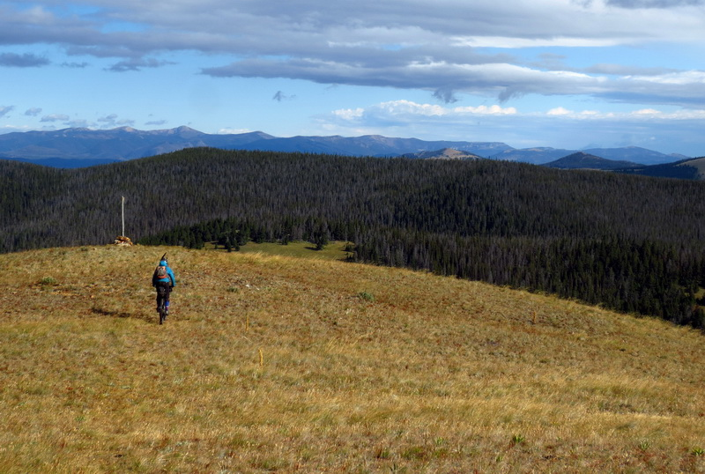
(Mountain biker on CDNST in UB10. Photo credit: Scott Morris.)

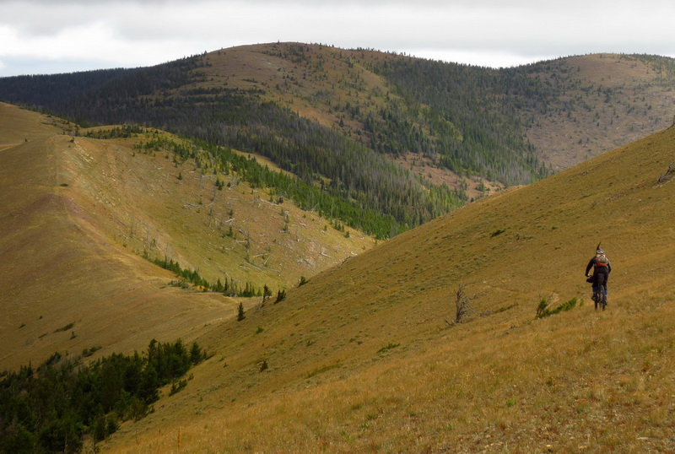
(Mountain biker on CDNST in UB10. Photo credit: Scott Morris.)

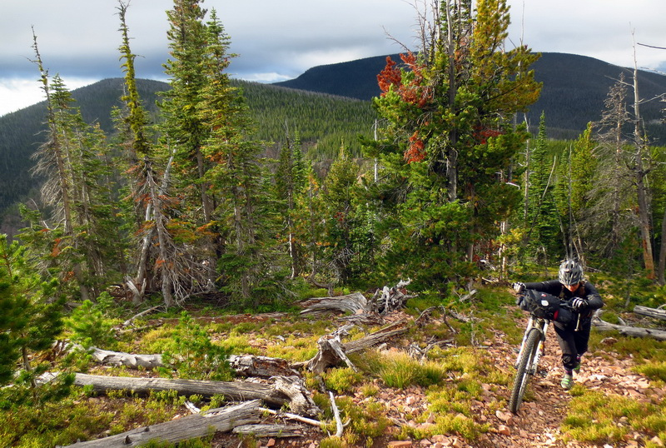
(Mountain biker on CDNST in UB10. Photo credit: Scott Morris.)

I respectfully request consideration of the access to and use of these trails in the HLCNF’s evaluation of Polygon UB10.

- Areas for mountain bike expansion within UB10

The Blackfoot Travel Plan identified all trails in this area for all non-motorized use and some motorized use trails and even future trails to be built as part of the great non-motorized recreation opportunity for the Upper Blackfoot GA. Re-routes of the Dalton Mountain Trail #467 will increase the sustainable enjoyment of this high ridge trail. It should be recognized that he Blackfoot Travel Plan identified all trails in this area for all non-motorized use and even future bicycle trails to be built as part of the great non-motorized recreation opportunity for the Upper Blackfoot GA.

Moreover, the CDNST must be managed according to the National Trails Act, the CDNST Study Reports and Final Environmental Impact Statement, and the CDNST Comprehensive Plan (as amended) for the purpose of providing: “A continuous, appealing trail route, designed for the hiker and horseman, but compatible with other land uses.” (HLCNF Forest Plan Assessment, Ch. 8, Existing Designated Areas, at 16 (emphasis added).) I respectfully request that the HLCNF recognize that another compatible and existing use on the CDNST is mountain biking.

In addition, I respectfully request the HLCNF also consider the possibility of designating and managing Polygon UB10 as a National Recreation Area. By administratively designating Polygon UB10 as a National Recreation Area, it would allow the area to be managed with an emphasis on its outstanding recreational attributes occurring in its natural condition. See 36 C.F.R. § 294.1 (2016). In particular, the HLCNF could maintain Polygon UB10’s wildlife and wilderness characteristics, while at the same time specifically permitting the continued use of semi-primitive non-motorized recreation.

